Dinaki Adventures Editor Instructions

Contents

The Map 3

Adding a background image 3

Deleting the background image 4

Changing the Aspect Ratio 5

Adding a Scene to the Map 6

Adding Background Music 7

Deleting Background Music 8

Changing Background Music Volume 9

Playing Background Music 10

Scenes 11

Creating a new Scene 12

Adding a Background Image 12

Deleting a Background Image 12

Adding Background Music 13

Deleting Background Music 13

Changing Background Music Volume 13

Playing Background Music 13

Error Messages 13

Adding an Activity to the Scene 14

Changing the Screen Name 15

Choosing a Reward Badge 16

Activities 18

Creating an Activity 18

Adding a Background Image 19

Deleting a Background Image 19

Adding Background Music 19

Deleting Background Music 19

Changing Background Music Volume 19

Playing Background Music 19

Error Messages 19

Changing the Screen Name 19

Setting the Dictionary Set 20

Setting a Reward Image 21

Setting the Reward Sound 22

Setting the Choices: Pairing Activity 23

Setting the Choices and Rounds: Matching Activity 24

Setting the Winning Score 25

Screen Items 26

Adding Text 26

Adding Images 30

Opacity and PNGs 30

Adding Hotspots 31

Changing the Hotspot Color 32

Adding Boxes 33

Changing the Selection Method 34

Changing the Order of Screen Items 35

Adding Hover Text: 36

Deleting a Screen Item 37

Adding Sound to a Screen Item 38

The Dictionary 39

Editing the Dictionary 39

Error Messages 39

Adding the Title 40

Adding the Image 41

Adding the Voices 42

Adding the Word 43

Clearing the Word 44

Editing a Word 45

Deleting a Word 46

The Dictionary Sets 47

Error Messages 47

Naming a Dictionary Set 48

Adding a Word to the Dictionary Set 49

Removing a Word from the Dictionary Set 50

Saving a Dictionary Set 51

Editing a Dictionary Set 52

Deleting a Dictionary Set 53

The Badges 54

Error Messages 54

Adding a Title to a Badge 55

Adding an Image to a Badge 55

Adding a Badge to the Badge List 57

Clearing a Badge 58

Editing a Badge 59

Deleting a Badge 60

The Editor 61

Changing the Editor Intro Image 61

Changing the About Page under the Help button 62

# 

# The Map

The Map is the first screen that the plyer sees after loading their profile. The Map will hold Scenes, which are areas of the Map that the player can visit. Good images for the map would be maps, blueprints, or other images that have areas of interest spread across a large area.

## Adding a background image

(Map, Scene, Activity)

To add a background image to the map, load the Map, and locate the **Add Background Image** button on the right-hand toolbar:

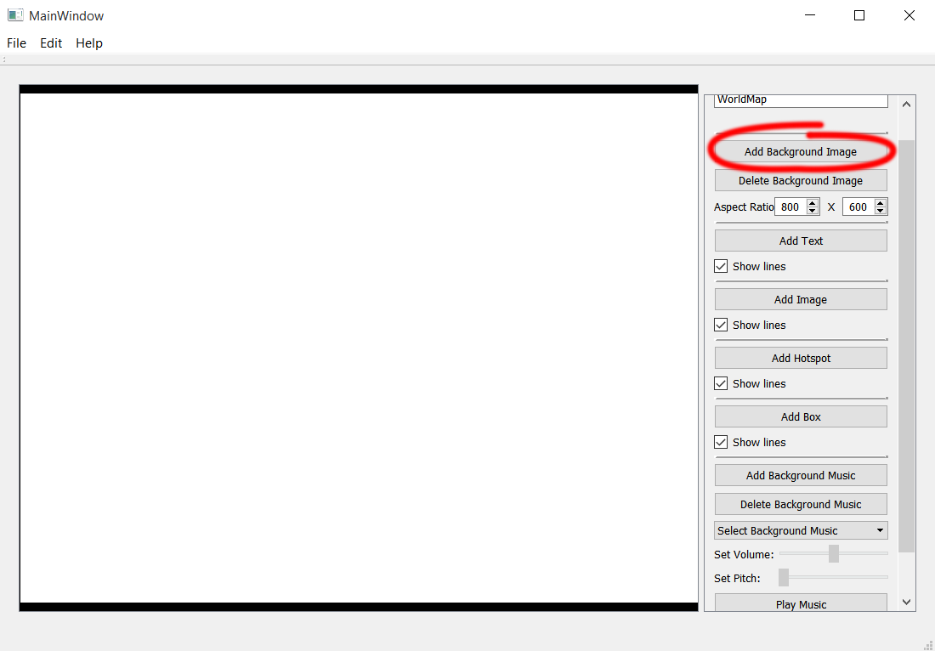

## Deleting the background image

(Map, Scene, Activity)

To delete the background image to the map, load the Map, and locate the **Delete Background Image** button on the right-hand toolbar:

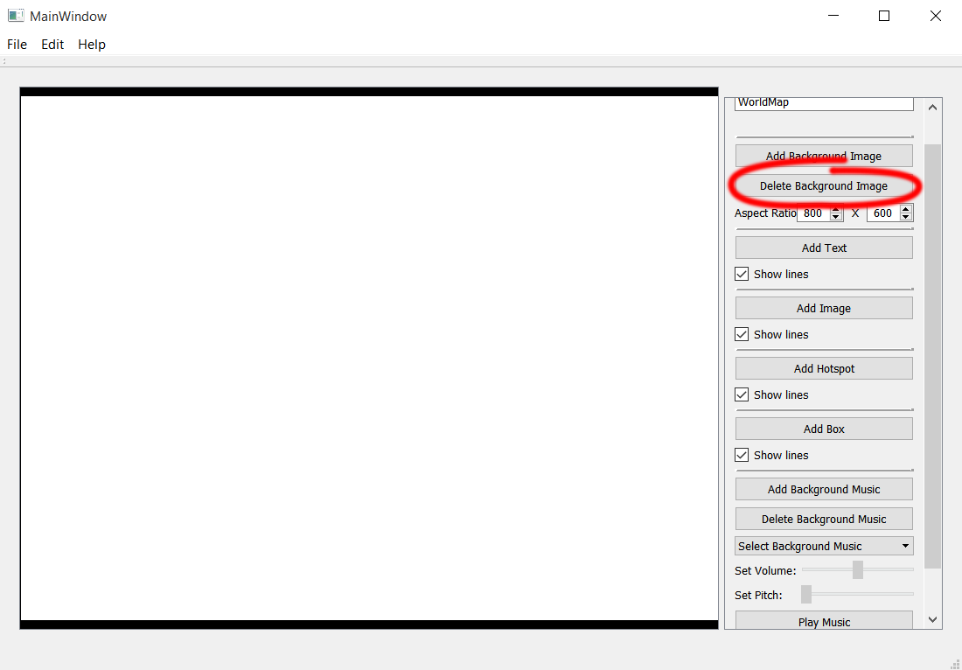

## Changing the Aspect Ratio

(Map)

The Map is where you can set the Aspect Ratio for the game. It is here that you will set it to the size of the monitor that the game will be played on.

To change the Aspect Ratio, adjust the numbers in the **Aspect Ratio** fields on the right-hand toolbar. The numbers can be changed with the up and down arrows, or by typing in the number. The first field is the width, and the second field is the height:

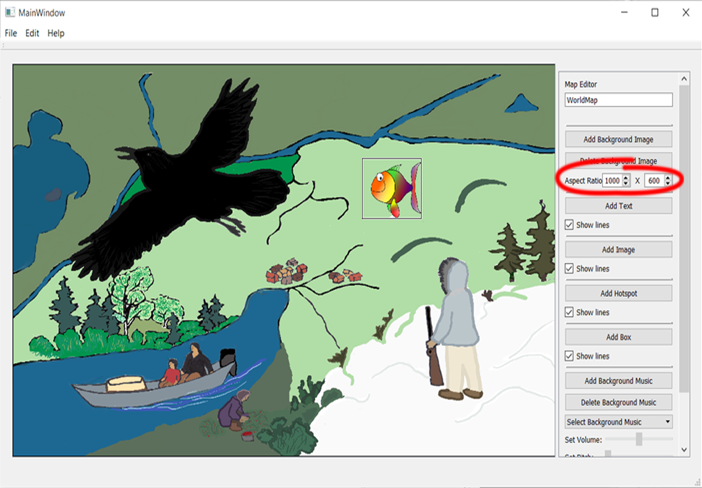

## Adding a Scene to the Map

(Map)

To add a Scene, you will need a Screen Item on the Map. To learn about Screen Items, go to the Screen Items section below on page 22. On the Map, select any screen item (Text, Image, Hotspot, or Box), and then select a Scene from the **Go To Scene** dropdown menu on the right-hand toolbar. Remember that to access the Scene, the screen item will need to be selectable:

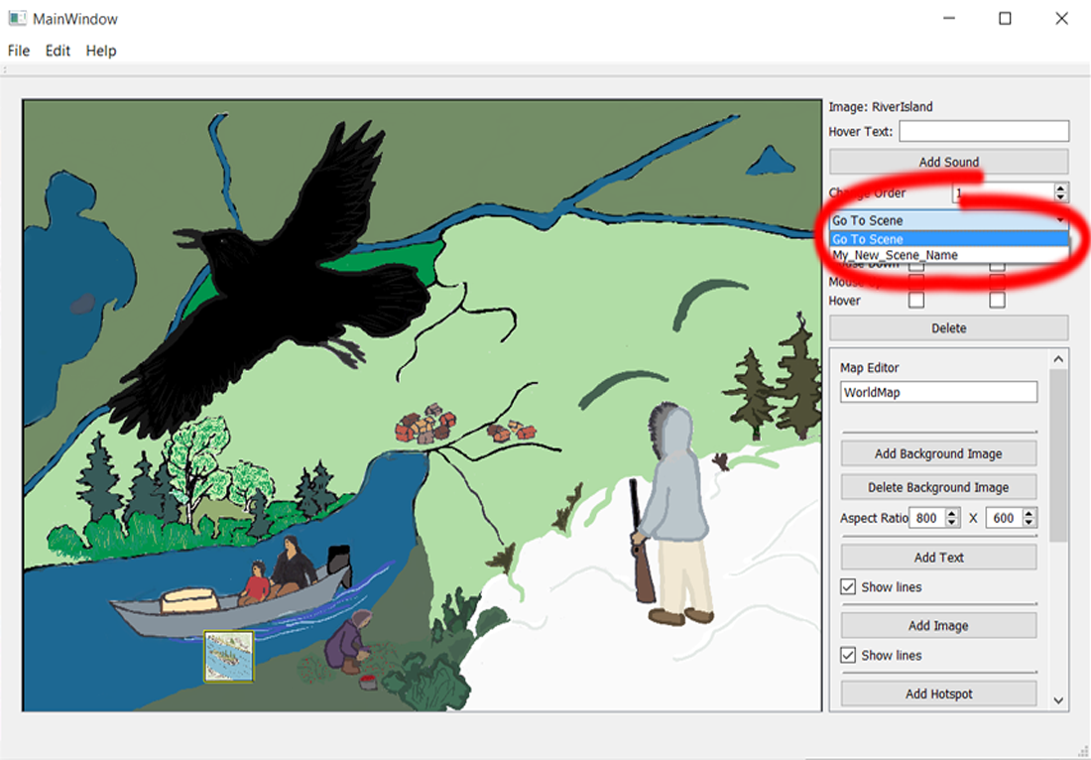

## Adding Background Music

(Map, Scene, Activity)

Background music is a list of sound files that play on loop when the player enters that screen, be it the Map, a Scene, or an Activity. To add files to the background music list, click the **Add Background Music** button on the right-hand toolbar. Once a file is selected, it will be copied to the folders used by the editor. In the Dinaki Adventures game, all of the background music items will be playing: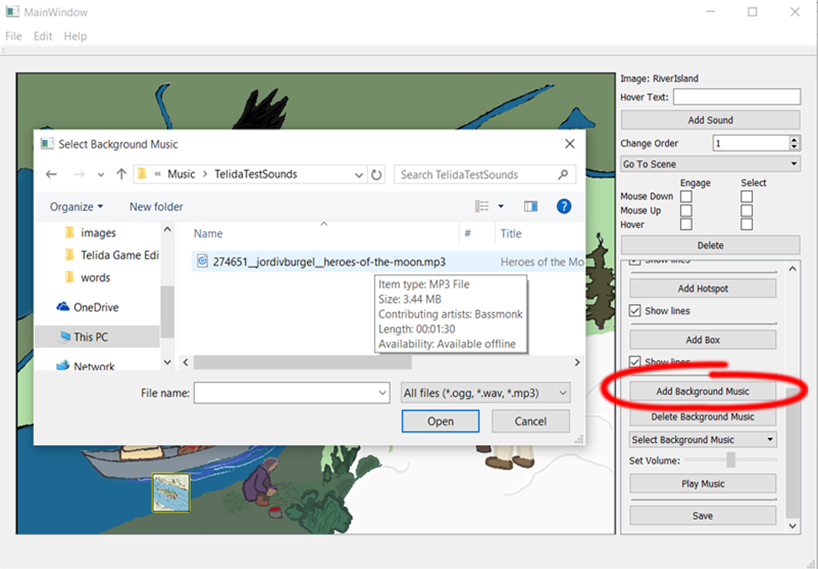

## Deleting Background Music

(Map, Scene, Activity)

To delete an item from the background music list, select the background music file you want to delete from the **Select Background Music** dropdown on the right-hand toolbar, and click the **Delete Background Music** button. Note that this does not delete the file from the folders used by the editor:

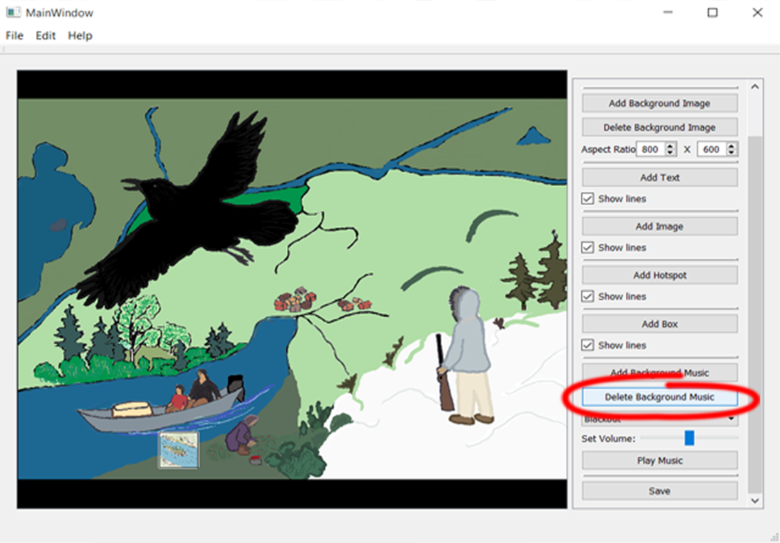

## Changing Background Music Volume

(Map, Scene, Activity)

To change the volume of an item from the background music list, select the background music file you want to change the volume of from the **Select Background Music** dropdown on the right-hand toolbar, and slide the **Set Volume** slider. Each music file has its own volume:

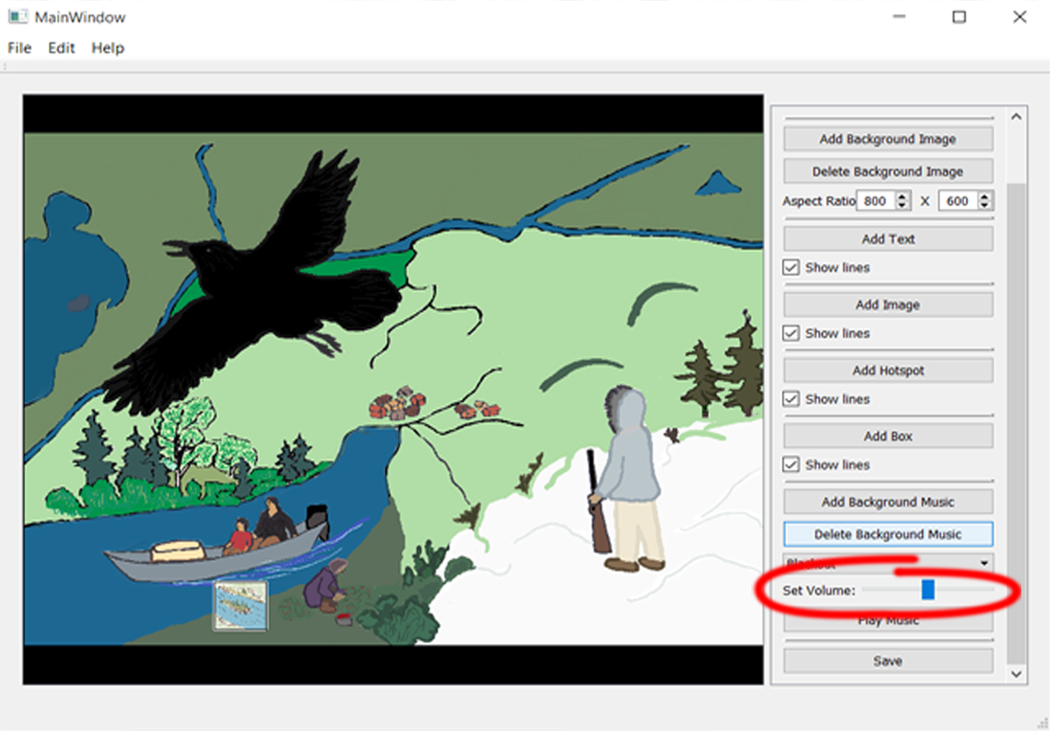

## Playing Background Music

(Map, Scene, Activity)

To play an item from the background music list, select the background music file you want to play from the **Select Background Music** dropdown on the right-hand toolbar, and click the **Play Music** button. Once pressed, it will become a **Stop Music** button. Each music file has its own playing state, so each music file can be playing at the same time:

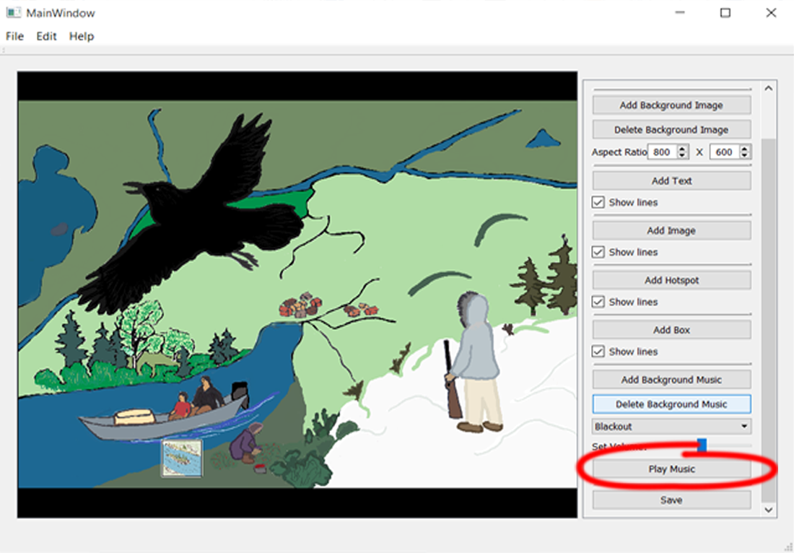

# Scenes

Scenes are areas on the Map that the player can visit, such as a river or a town. Good images for a Scene would be towns, parks, or other images that have areas of interest in one defined place.

## Creating a new Scene

To create a Scene, click the **File** button on the top toolbar, and then select **New Scene**. The requirements for a new Scene are that the Scene contain a name that is unique compared to all other Scenes, and the name cannot be blank:

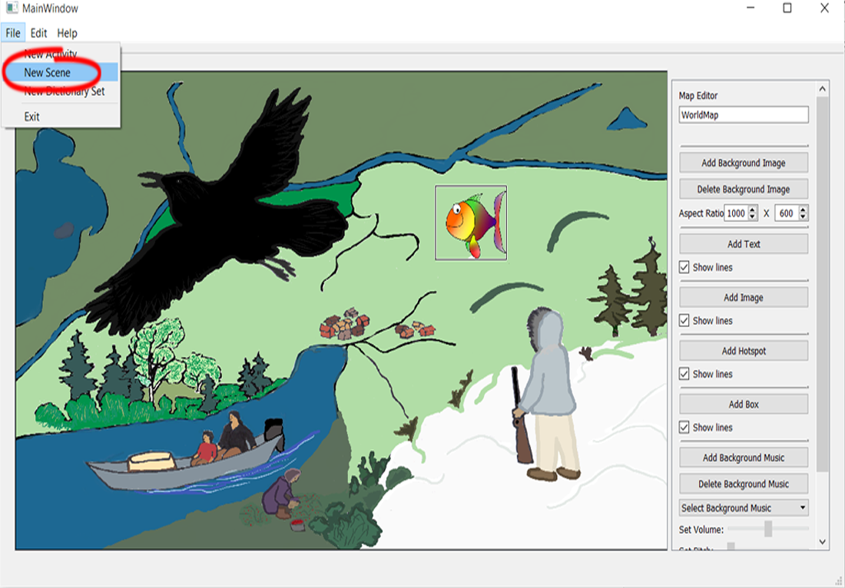

## Adding a Background Image

Explained on page 3

## Deleting a Background Image

Explained on page 4

## Adding Background Music

Explained on page 7

## Deleting Background Music

Explained on page 8

## Changing Background Music Volume

Explained on page 9

## Playing Background Music

Explained on page 10

## Error Messages

(Scene, Activity, Dictionary, Dictionary Set, Badges)

Error Messages display when a Scene, Activity, the Dictionary, a Badge, or a Dictionary Set is trying to be saved without a needed field of information. Look at the error message (you may need to scroll up), and correct the mistake. Then try saving again:

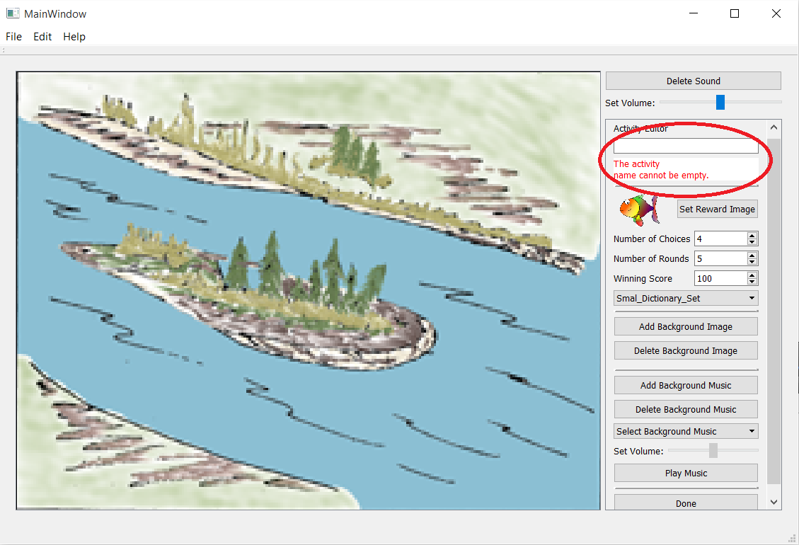

## Adding an Activity to the Scene

(Scene)

To add an Activity to the Scene, select any screen item (Text, Image, Hotspot, or Box), and then select an Activity from the **Go to Activity** dropdown menu:

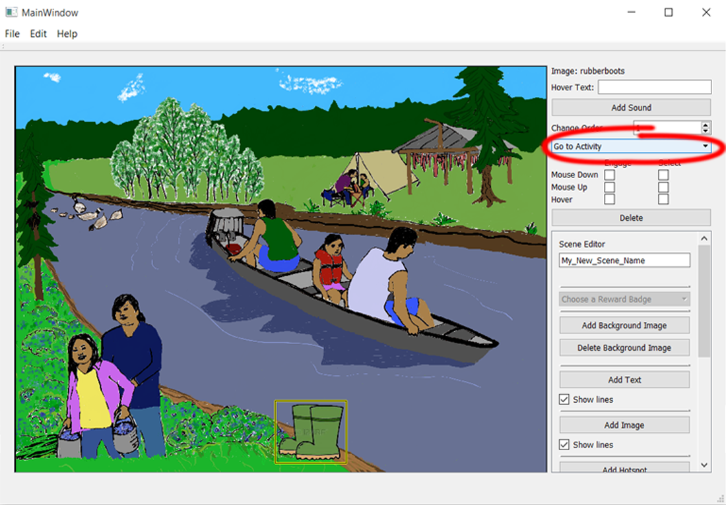

## Changing the Screen Name

(Scene, Activity)

To change the name of the Scene, locate the field under **Scene Editor**, and type in the new name. Use underscores ( _ ) in place of spaces between words, so “My New Scene Name” would be “My_New_Scene_Name”:

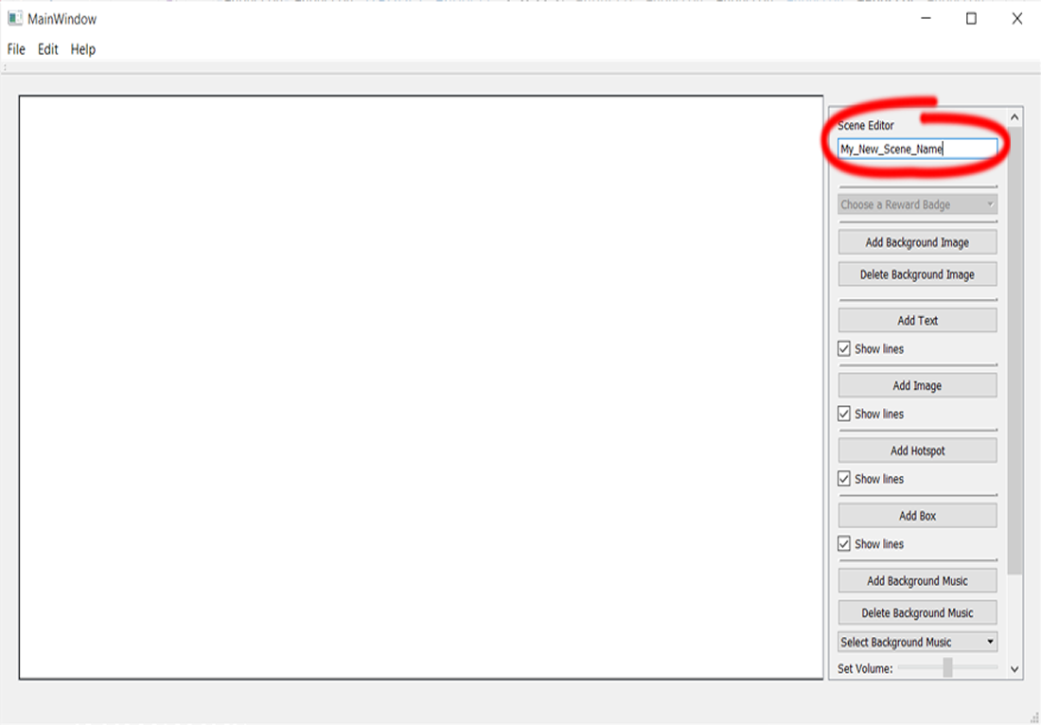

## Choosing a Reward Badge

(Scene)

A reward Badge is what a player will receive after completing all of the Activities with a high enough score (and thus earning the Badge Pieces). To set the reward Badge, click on the **Choose a Reward Badge** dropdown, and select a Badge. There must be at least one screen item that has an Activity:

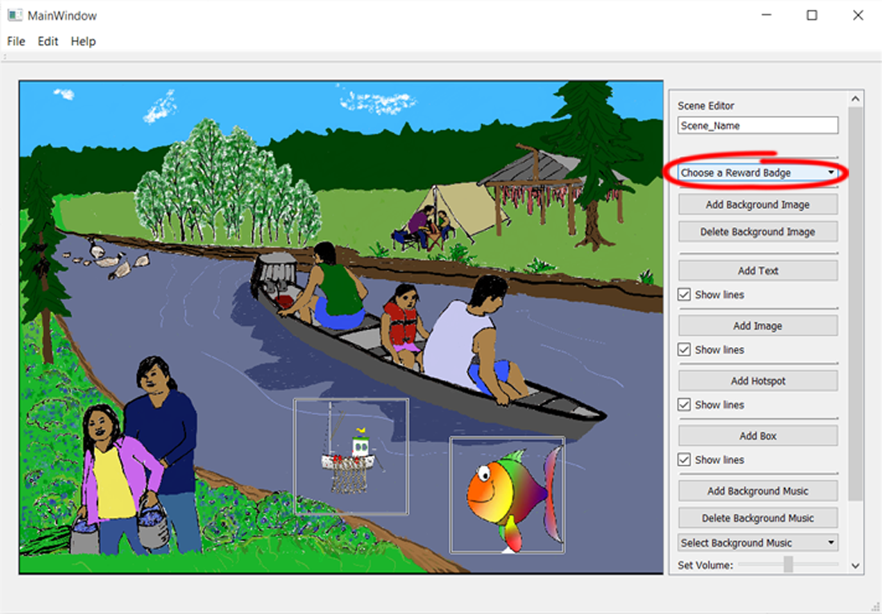

# Activities

Activities are where the player plays one of the two Game Types, Matching and Pairing. Good images for an Activity would be river spots, house interiors, or other images that have a small space with themed items (fishing, groceries, etc).

## Creating an Activity

To create an Activity, click on **File** in the top toolbar, and then select **New Activity**. The requirements for a new Activity are a unique name that isn’t empty, a Dictionary Set, and a reward Image:

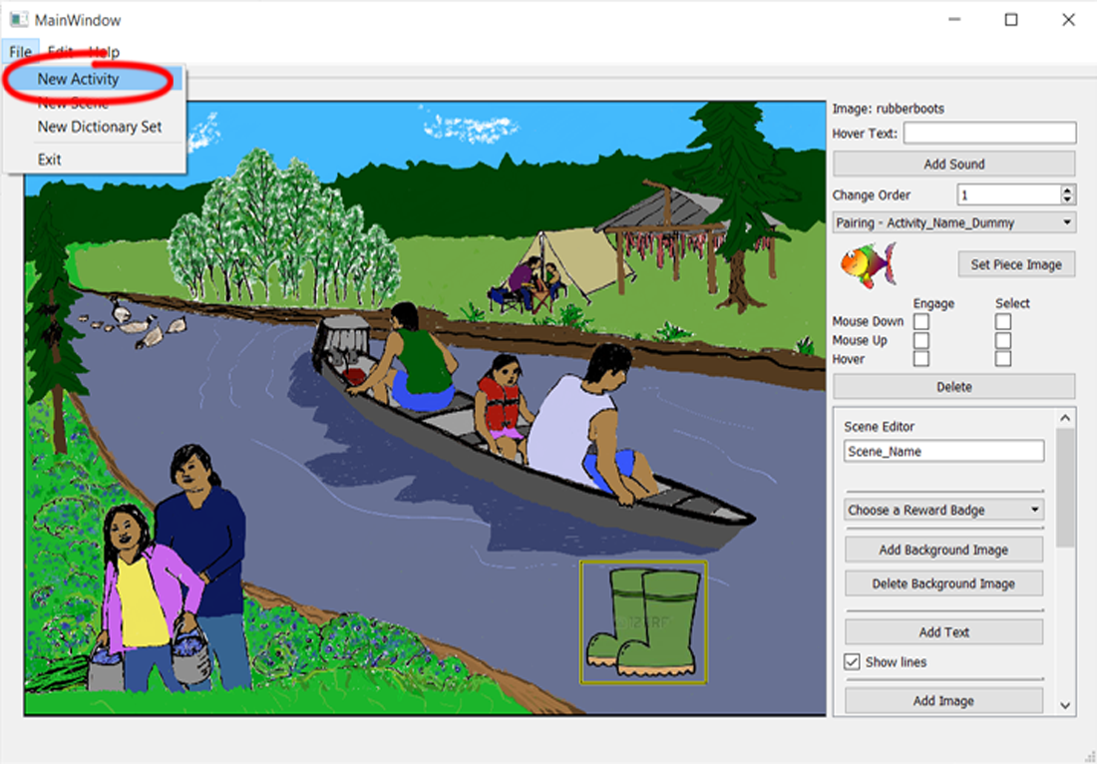

Then select the Game Type:

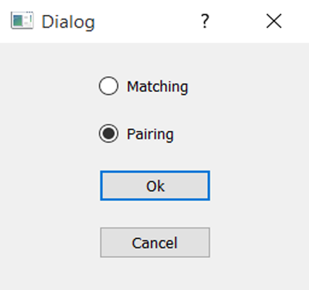

## Adding a Background Image

Explained on page 3

## Deleting a Background Image

Explained on page 4

## Adding Background Music

Explained on page 7

## Deleting Background Music

Explained on page 8

## Changing Background Music Volume

Explained on page 9

## Playing Background Music

Explained on page 10

## Error Messages

Explained on page 13

## Changing the Screen Name

Explained on page 15

## Setting the Dictionary Set

(Activity)

Each Activity requires a Dictionary Set, containing Words that the Activity picks from to use in the game. To choose the Dictionary Set for an Activity, click on the **Choose a Dictionary Set** dropdown in the right-hand toolbar, and select the Dictionary Set that has the Words you want used in the Activity:

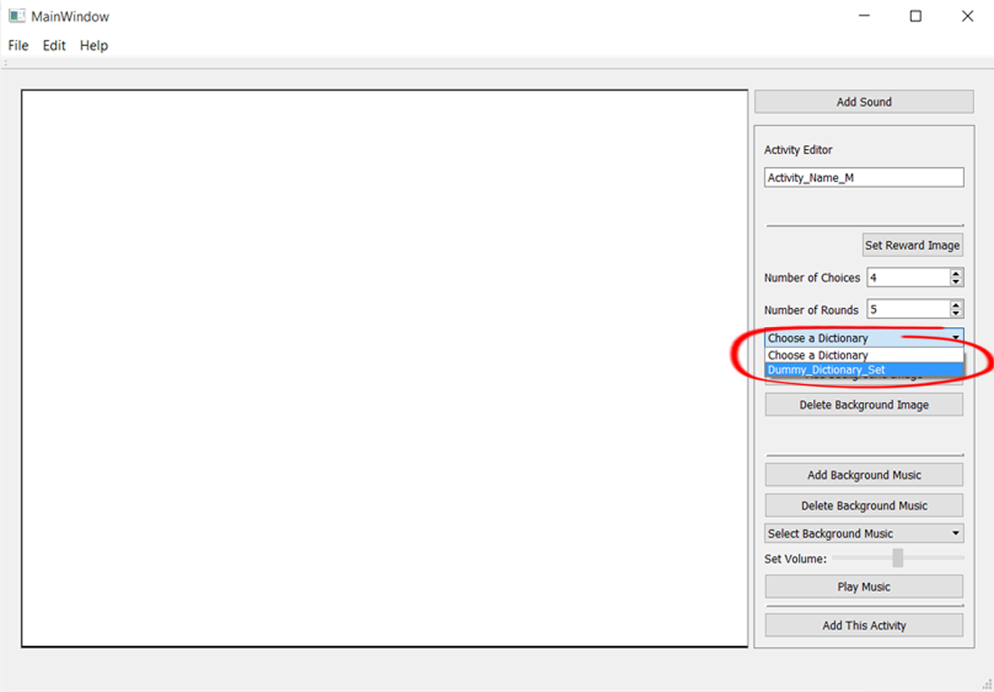

## Setting a Reward Image

(Activity)

A reward image appears each time the player gets a correct answer while playing. To add a reward Image, click the **Set Reward Image** button on the right-hand toolbar:

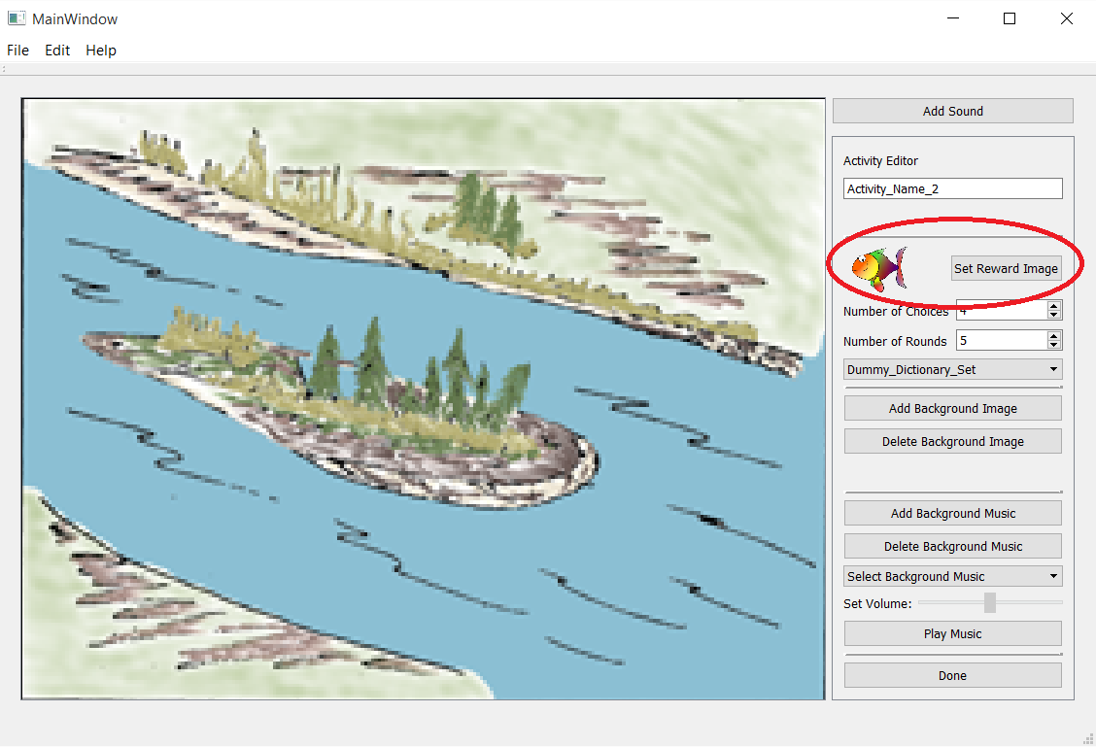

## Setting the Reward Sound

(Activity)

A reward Sound plays each time the player gets a correct answer. To add a reward Sound, click the **Add Sound** button on the right-hand toolbar:

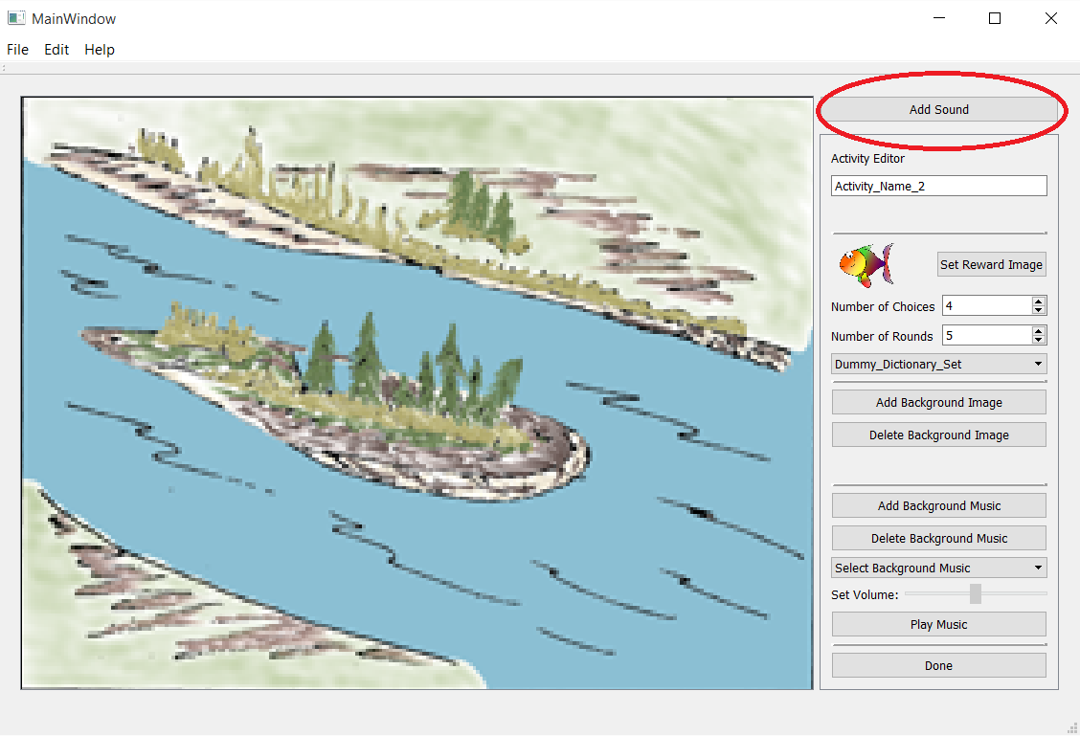

Once added, the Sound can be deleted and have its Volume changed:

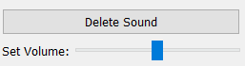

## Setting the Choices: Pairing Activity

The Activities can have their difficulty adjusted by changing the number of Choices available to the player. For a Pairing Activity, the Choices will be the number of Word-Image associations that the player must make. Make sure not to have the Choices exceed the number of Words in the Dictionary Set:

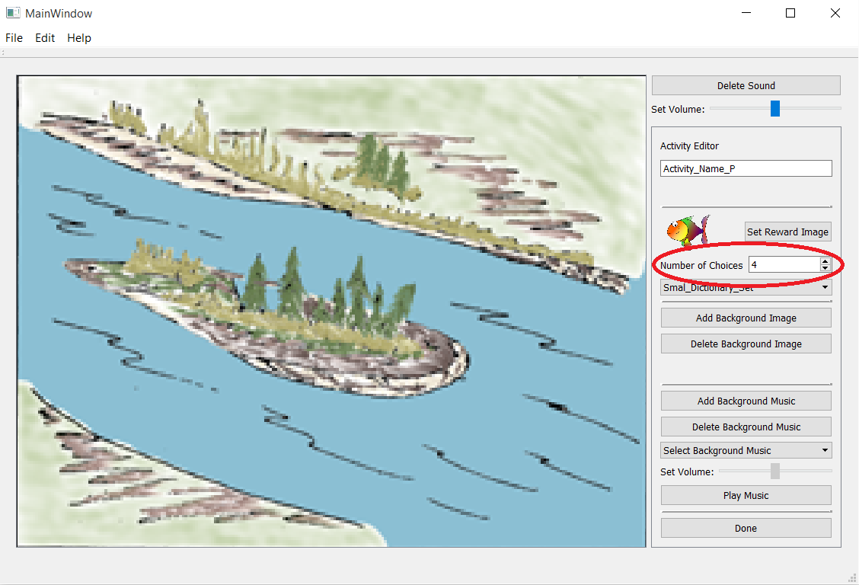

And in the game player this is seen as 4 Images to 4 Words:

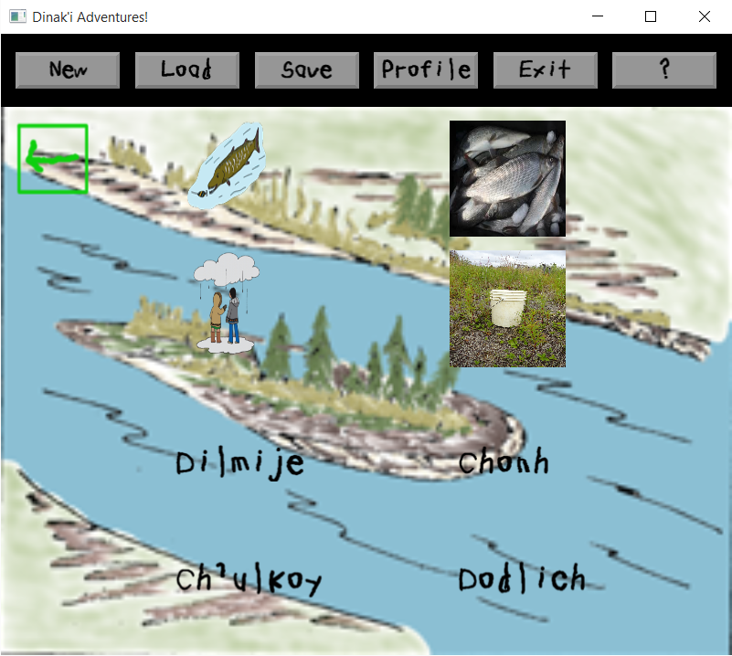

## Setting the Choices and Rounds: Matching Activity

The Activities can have their difficulty adjusted by changing the number of Choices and Rounds available to the player. For a Matching Activity, the Choices will be the number of Words that the player must choose from to match to the Image. The Rounds will be how many times they will match a Word to an Image. Make sure not to have the Choices exceed the number of Words in the Dictionary Set:

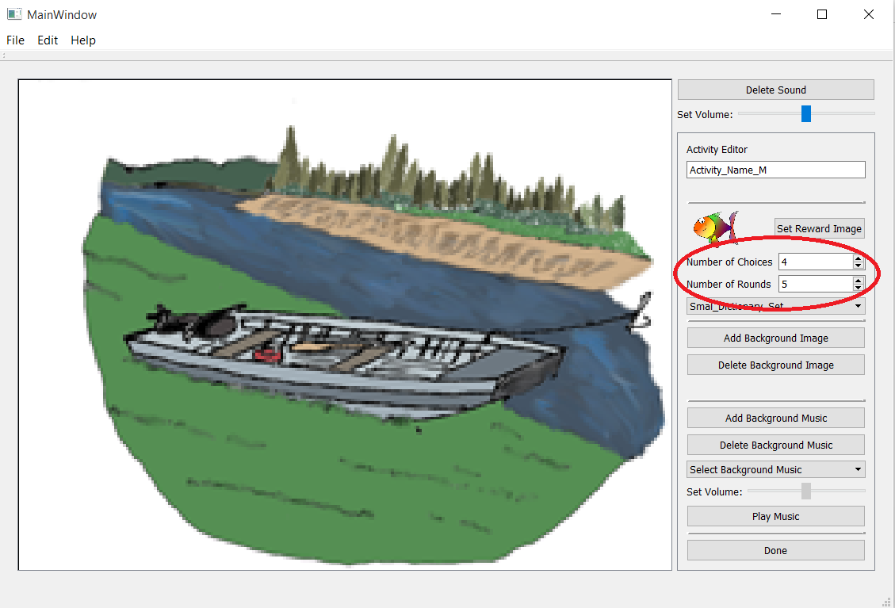

And in the game, the player will have 4 Choices of Words, and will have 5 Rounds, where each new Round randomly selects new Words and a new Image to match to:

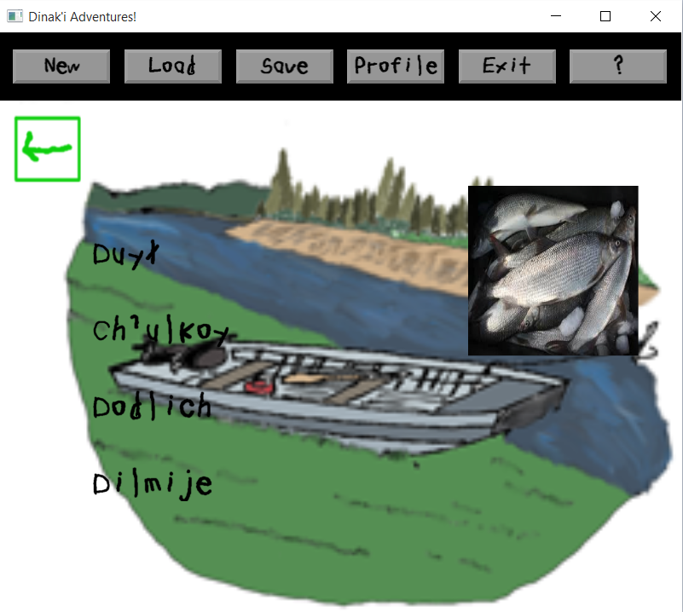

## Setting the Winning Score

(Activity)

The Winning Score is the score required to earn the badge for this Activity. Players will see their score at the end of each Activity, and if they have received a Badge Piece or a completed Badge, it will appear in their profile screen in the game player:

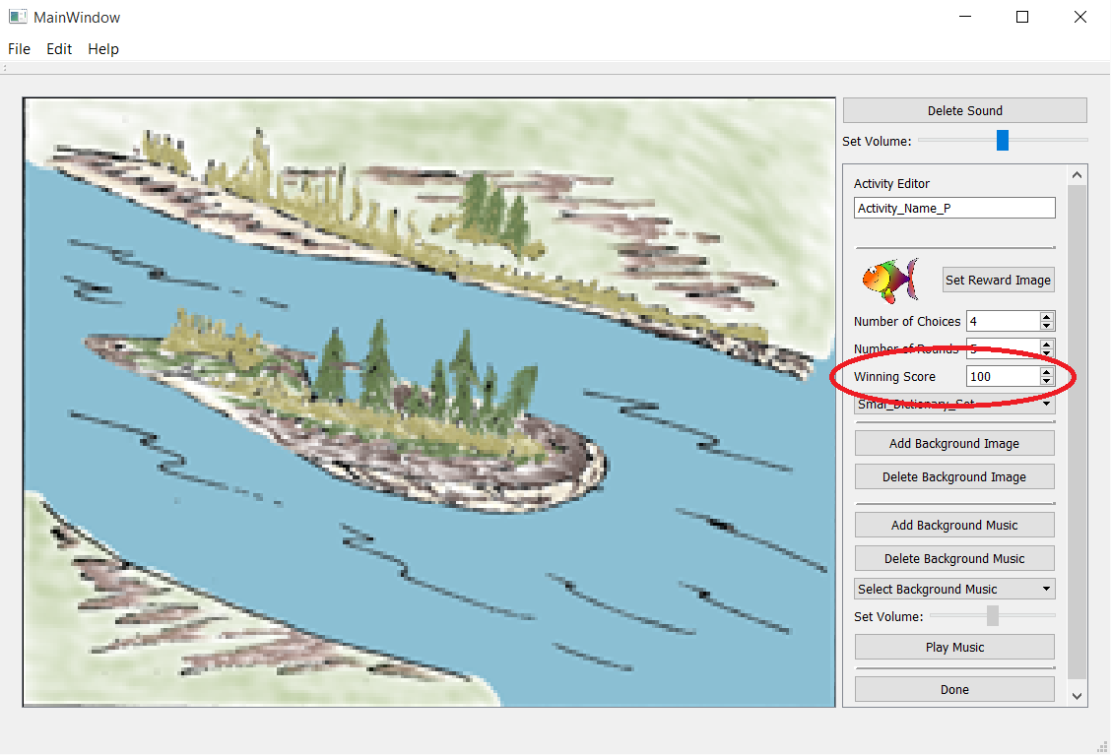

# Screen Items

Screen Items are Text, Images, Hotspots, and Box objects that can be added to the Map or a Scene. They can be used to go to another Screen, such as the Map to a Scene, or just to add to the background picture.

## Adding Text

To add text, locate the **Add Text** button on the right-hand toolbar:

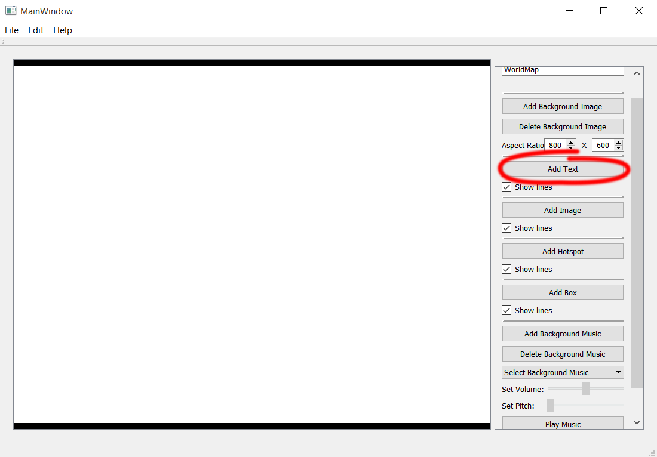

This will create an outlined box with text inside:

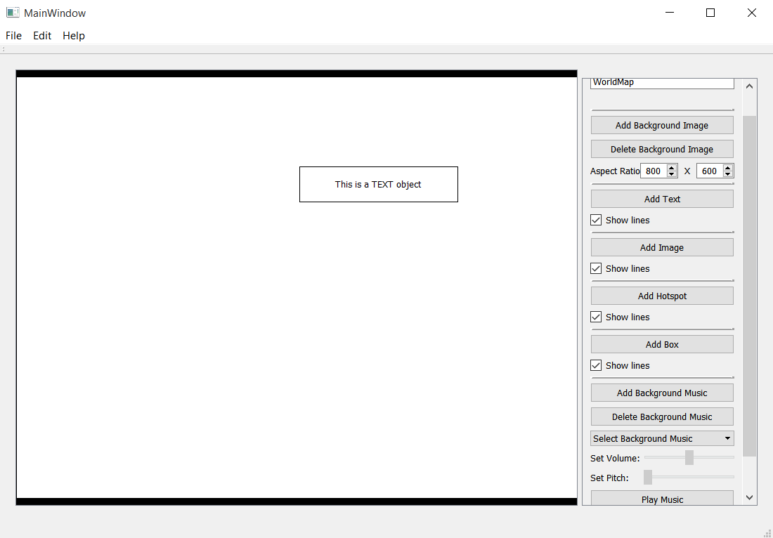

To resize the Text, place the cursor over the text box. When the small grey squares appear, click on them and then drag the cursor until the box is the desired width. The Text will fit inside the width of the box. While the height of the box has no effect, the text height will be proportional to its width. Text will always be one line, and will not have line breaks:

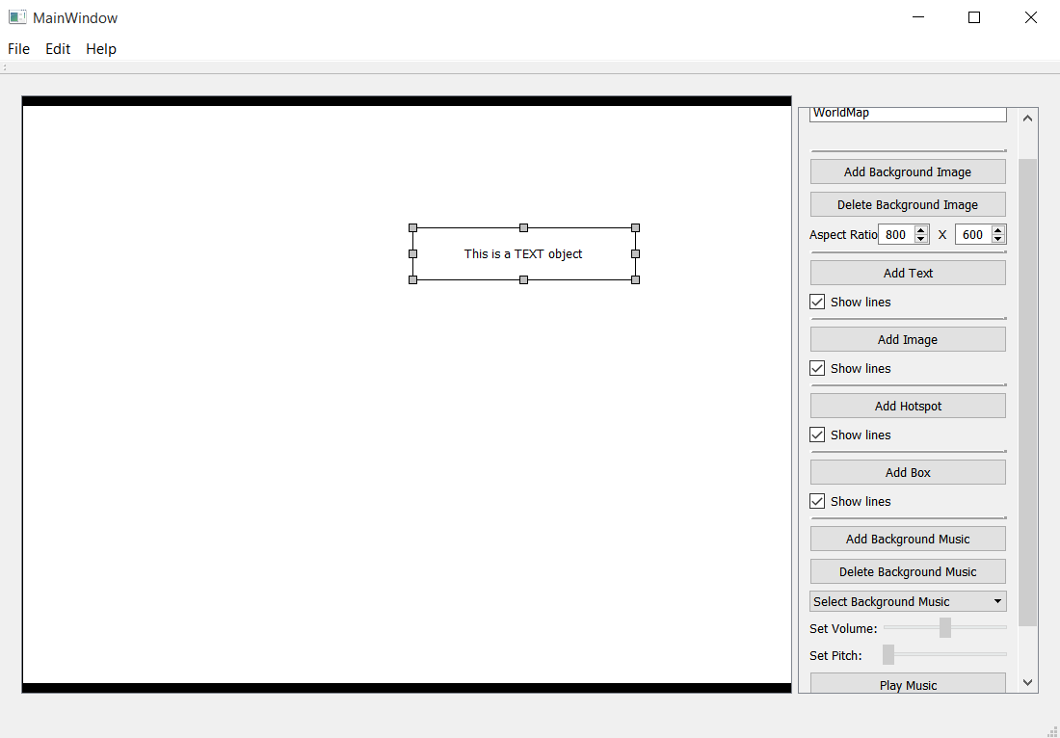

To edit the text in the text object, left-click the Edit Text button on the toolbar. This will bring up a window where you can edit the text:

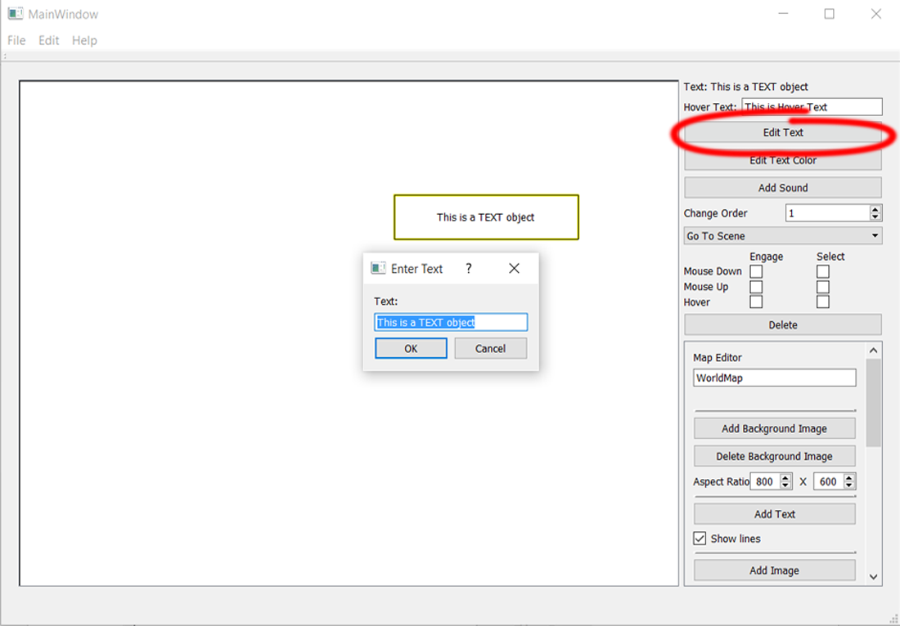

To edit the text color, left-click the Edit Text Color button on the toolbar. This will bring up a window where you can edit the text color: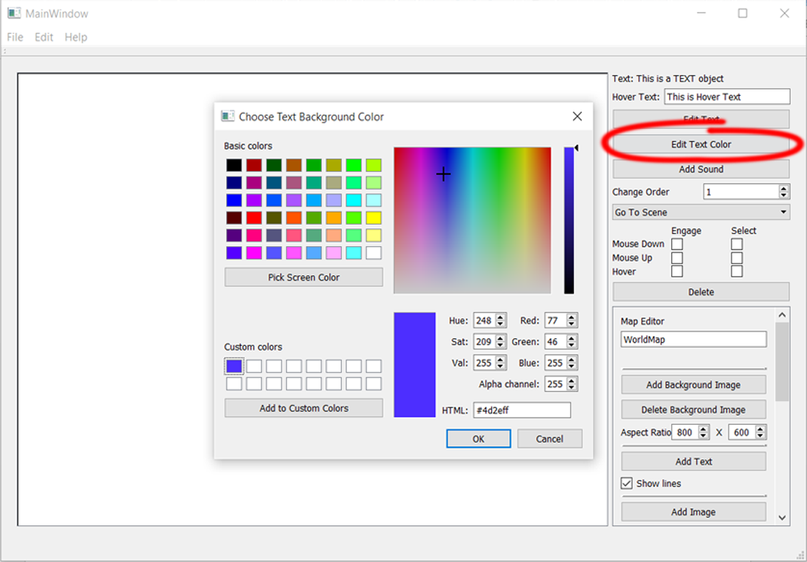

After the text color has been changed, the text inside the text box will be the new color:

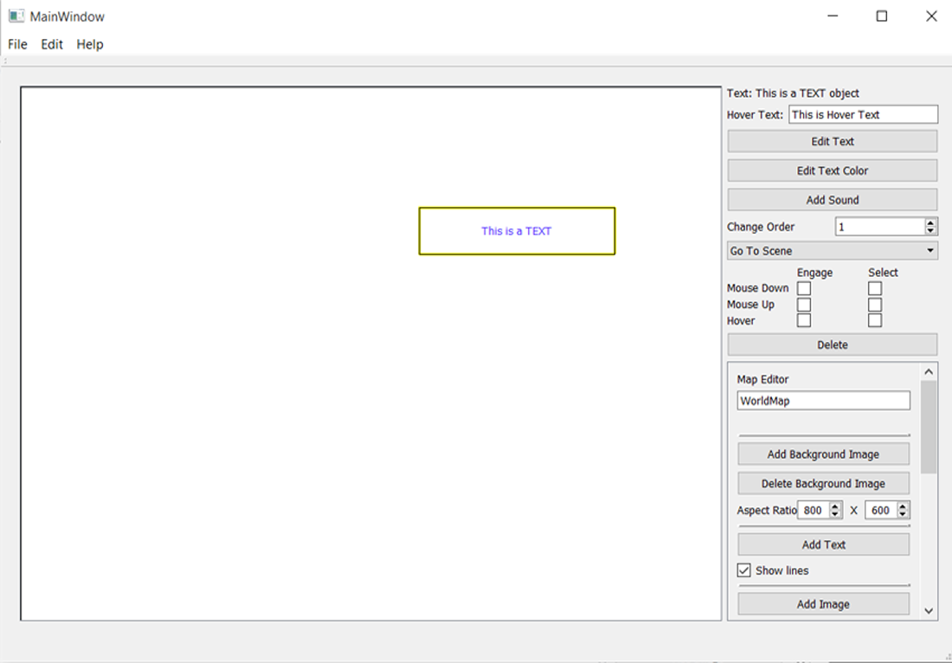

If the text object can respond to clicks from the player, the text object can play a sound when it is clicked. To add a sound to the text object, click the **Add Sound** button on the right-hand toolbar. This will bring up a window where you can select the sound file to play when the text object is clicked:

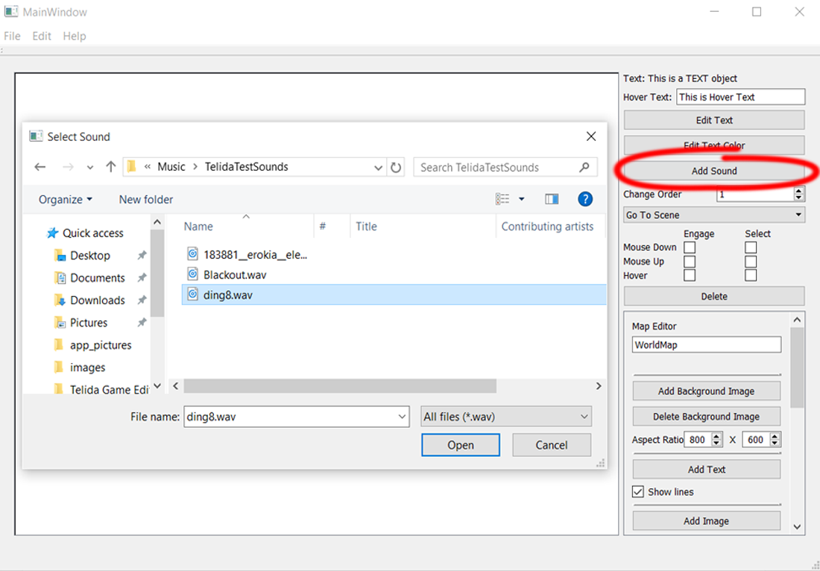

## Adding Images

To add an image, locate the **Add Image** button on the right-hand toolbar. This will create a small image that can be moved and resized:

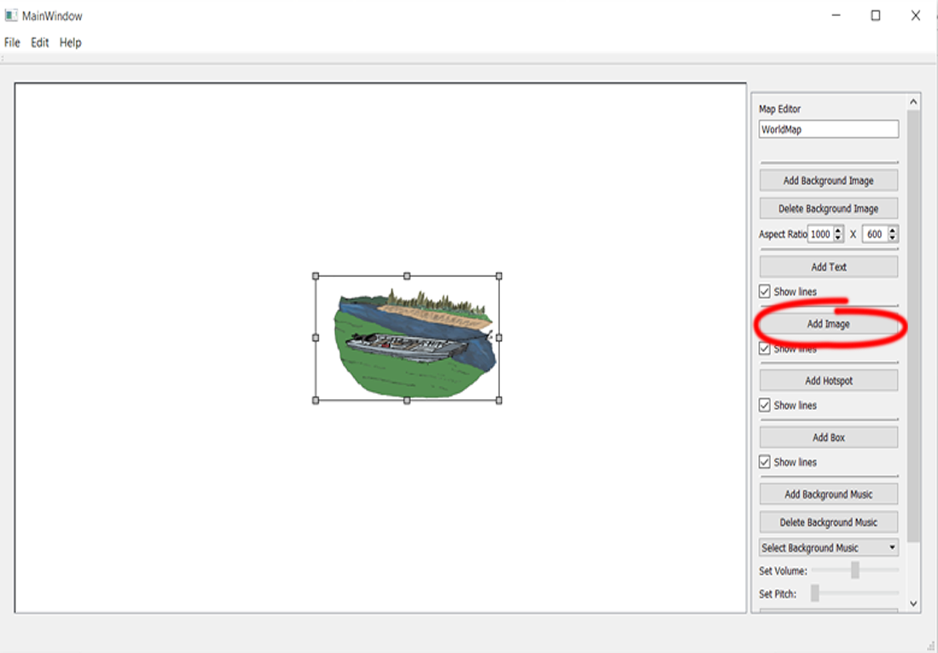

### Opacity and PNGs

An important thing to note about adding any image into the game, is whether or not the image has opacity. An image file that has opacity, such as a .png, will have parts that do not block the image behind it. This means that an image can more seamlessly be put onto a larger image. For example, the below image on the left has a fish image with no opacity, such as a .jpg, so the background appears white. The below image on the right however, has the fish image as an image with opacity, such as a .png, so there is no white background blocking the image behind it:

|  |  |
| --- | --- |
|  |  |

## Adding Hotspots

To add a hotspot, locate the **Add Hotspot** button on the right-hand toolbar. This will create a hotspot, a circular glow, which can be moved and resized:

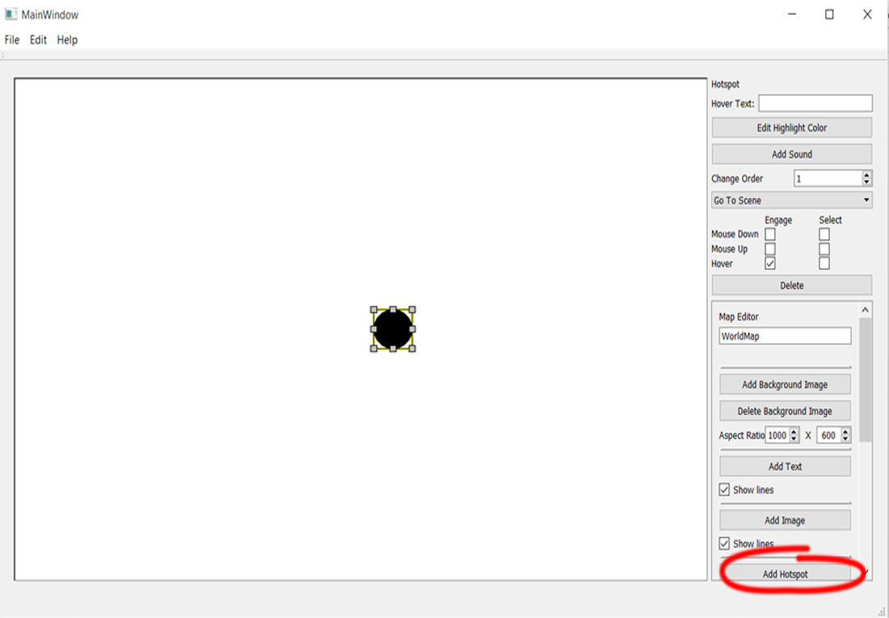

In the editor this appears as a solid circle, and it will only appear when it is engaged. In this example, I have set the Engage on Hover, so while the mouse is hovering over it, it will appear.

## Changing the Hotspot Color

To change the color of the hotspot, select the **Edit Highlight Color** button, and select the desired color from the window that comes up: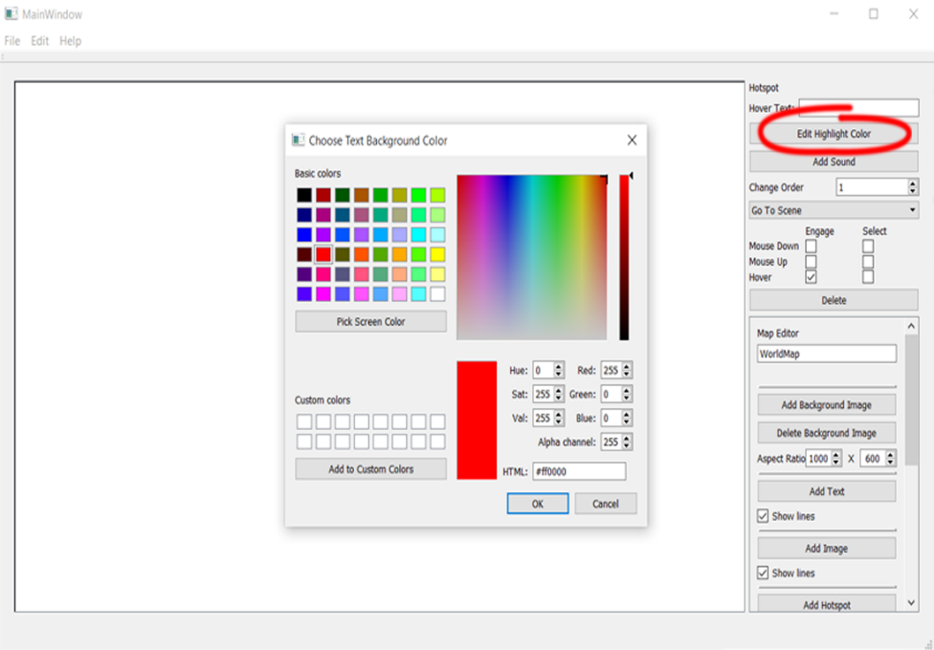

Now when the cursor hovers over the hotspot, it shows the new color:

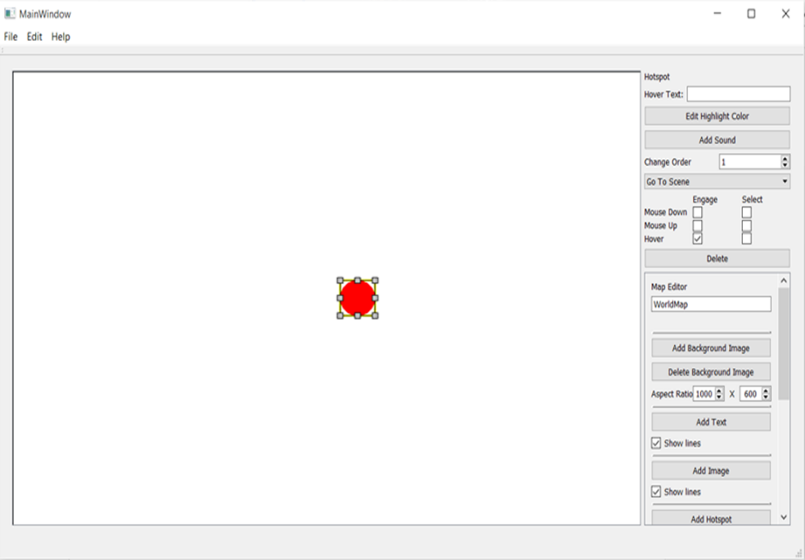

## Adding Boxes

To add a box, locate the **Add Box** button on the right-hand toolbar. This will create a simple box to frame things in the screen. It can be moved and resized:

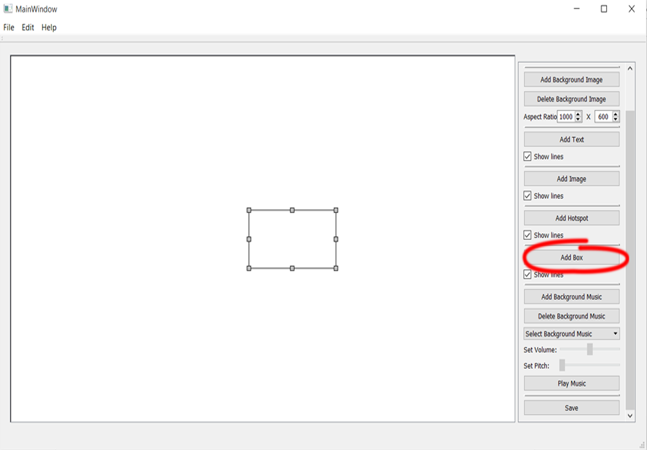

## Changing the Selection Method

To change the selection method for a screen item (Text, Image, Hotspot, or Box), check the small boxes for the selection options located in the right-hand toolbar:

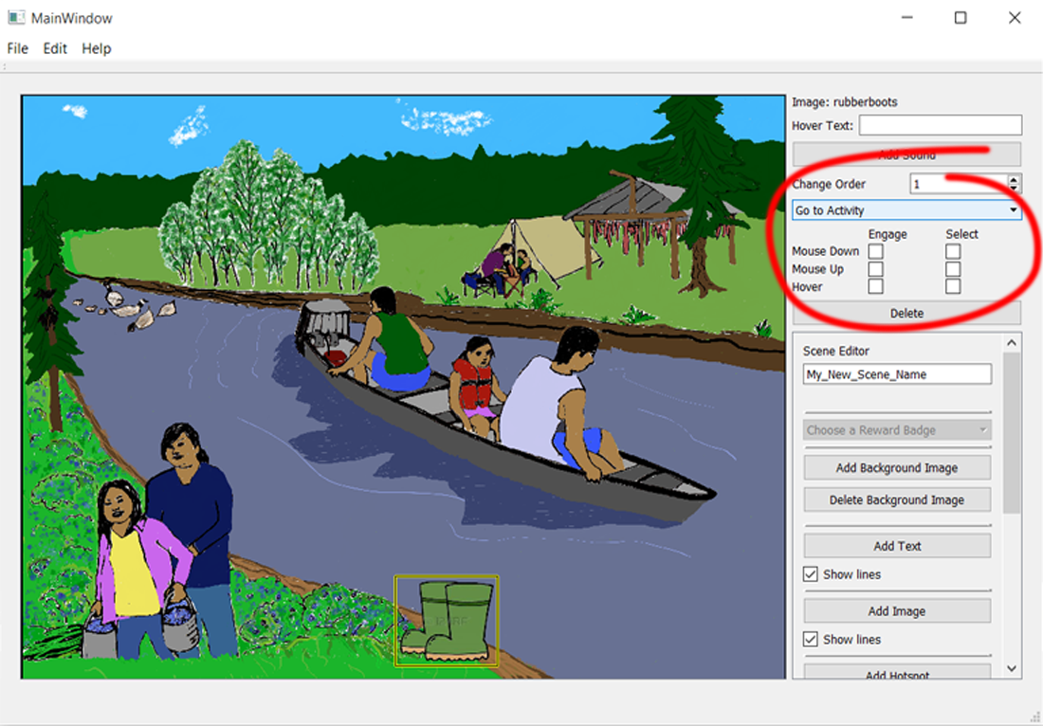

**Engage**

Highlights the screen item (makes hotspots appear, make text highlighted)

**Select**

Selects the screen item (goes to Scene or Activity, plays a sound)

**Mouse Down**

Activates the screen item when the left mouse button is pressed down

**Mouse Up**

Activates the screen item when the left mouse button is released from being pressed

**Hover**

Activates the screen item when the cursor is placed over the screen item

**Note:**

The most popular combination is Engage on Hover, and Select on Mouse Up.

## Changing the Order of Screen Items

The change the order that screen items appear (which ones are in front of which), change the value of a screen item in the **Change Order** field. The higher the value, the closer it is to the front compared to the other screen items:

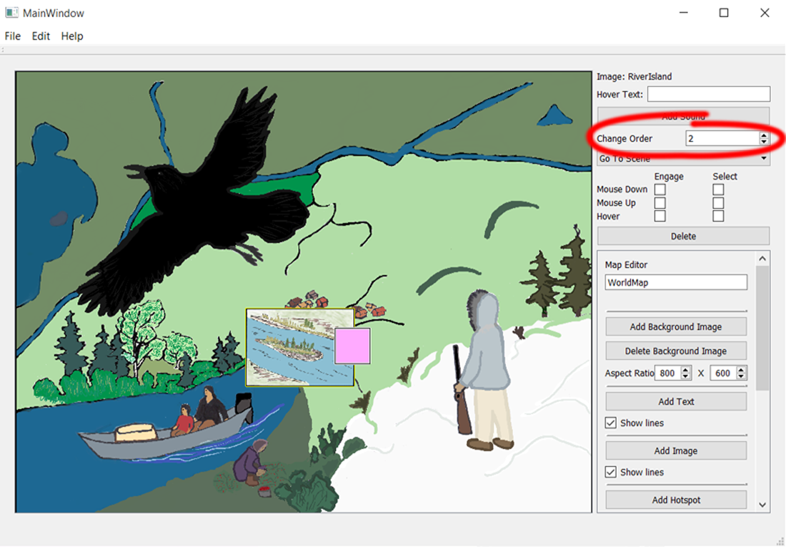

Increasing the order value of the small river Image makes it appear over the pink Box:

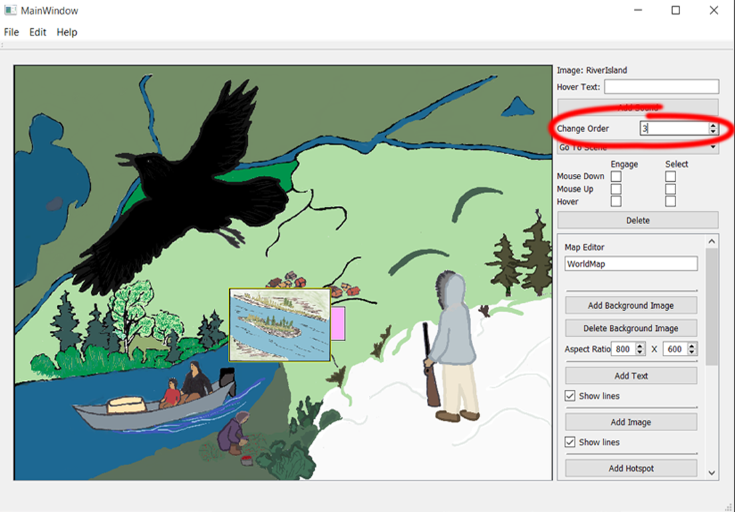

## Adding Hover Text:

To add hovering text to a Screen Item, select the Screen Item, and then left-click inside the Hover-Text text area:

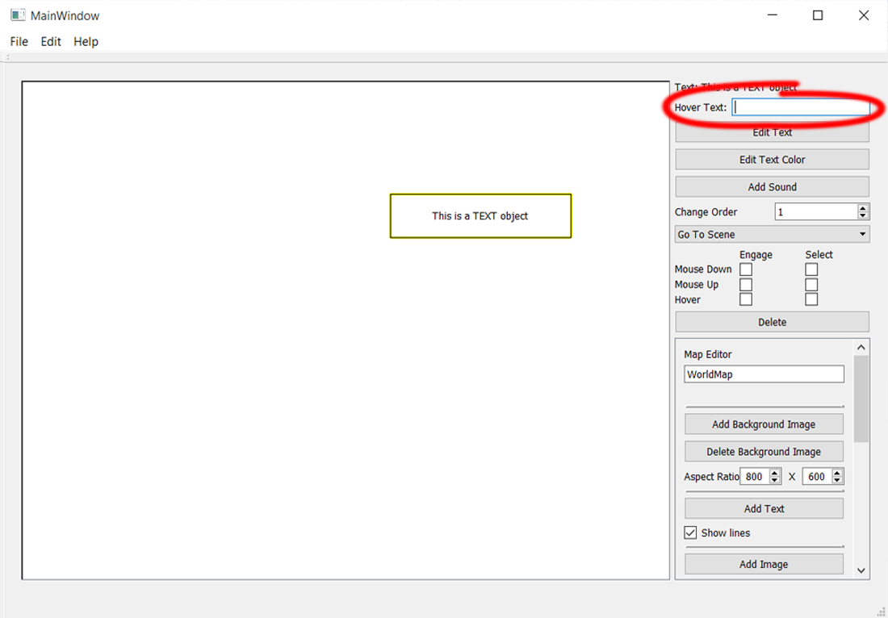

Now when you hover the cursor over the Screen Item, you will see a tool-tip with the Hover Text you set:

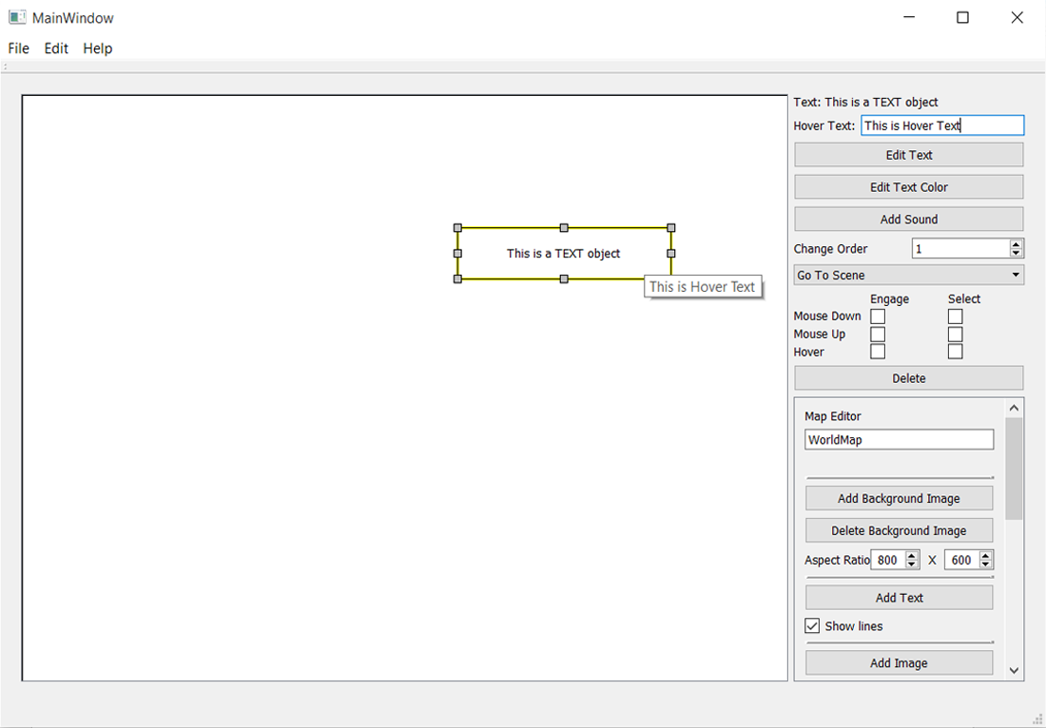

## Deleting a Screen Item

To delete a Screen Item, you must click the **Delete** button on the toolbar:

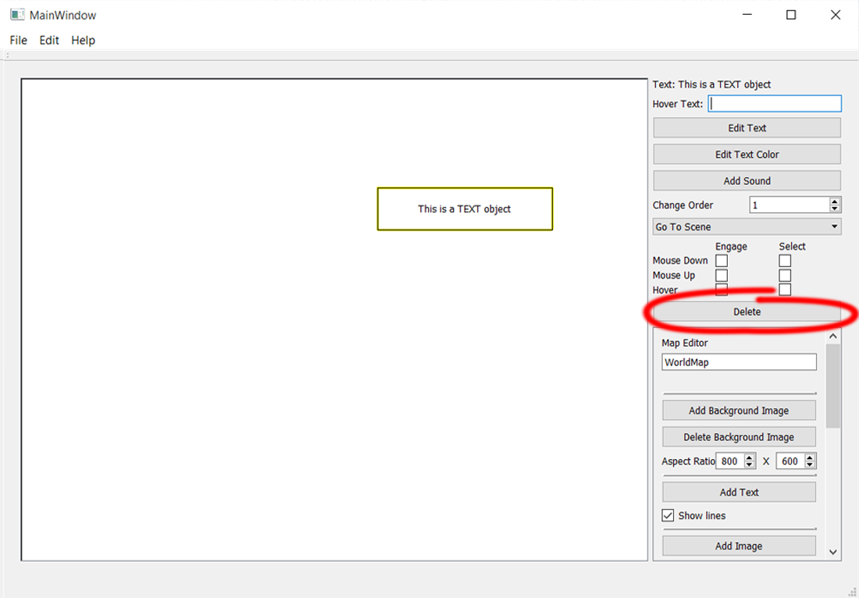

## Adding Sound to a Screen Item

A screen item that can be selected (whether it takes the player anywhere or not) can have a sound attached to it which plays when the screen item is selected. To add a Sound, select a screen item, and then click on the **Add Sound** button on the right-hand toolbar:

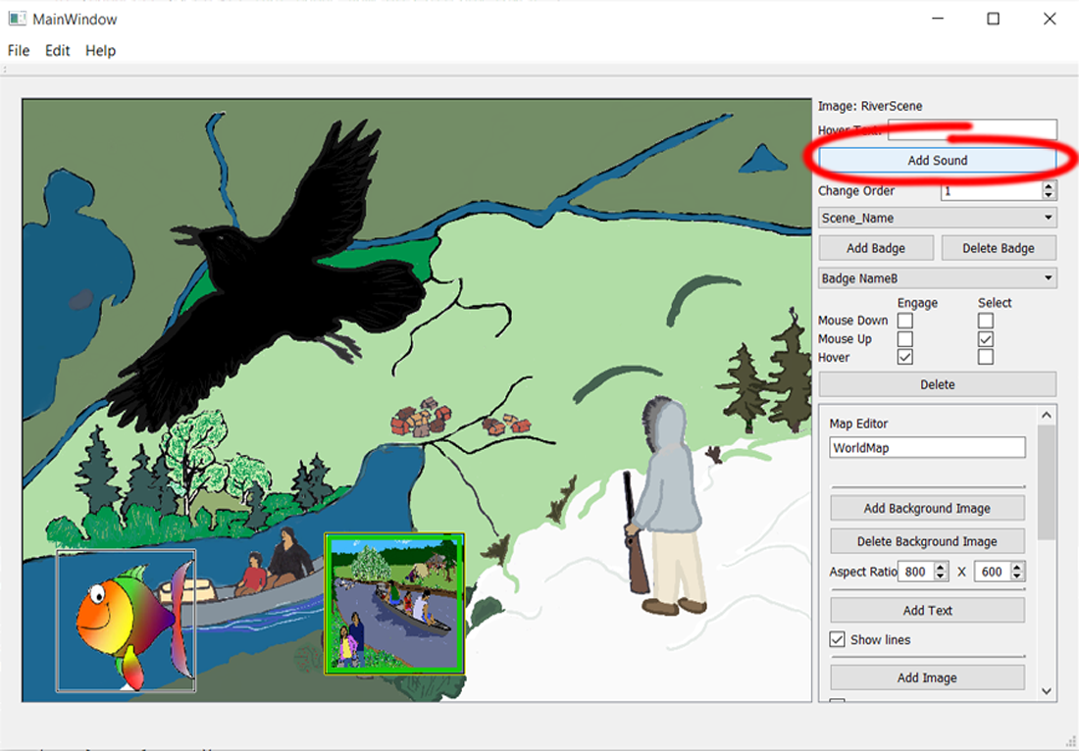

You will then have the option to delete the Sound, or to change its volume:

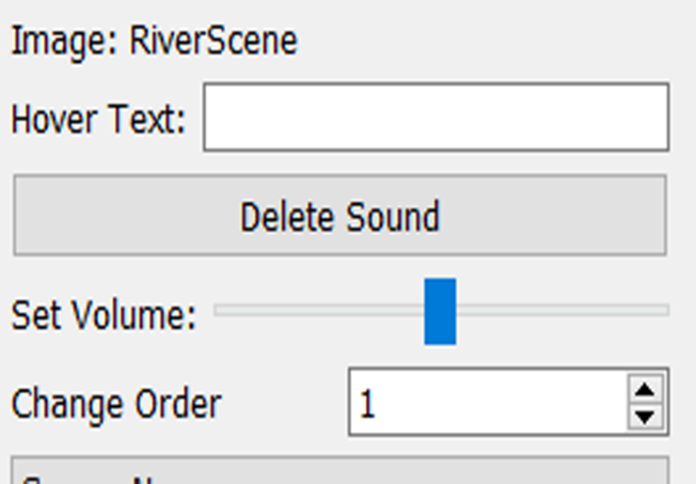

# The Dictionary

The Dictionary is where all of the words for the game are stored.

## Editing the Dictionary

To add or remove words from the Dictionary, go to **Edit** on the top tool bar, and select **The Dictionary**. To add a new Word, or save changes to an existing one, the Title, Image, Female Voice, and Male Voice must all be filled:

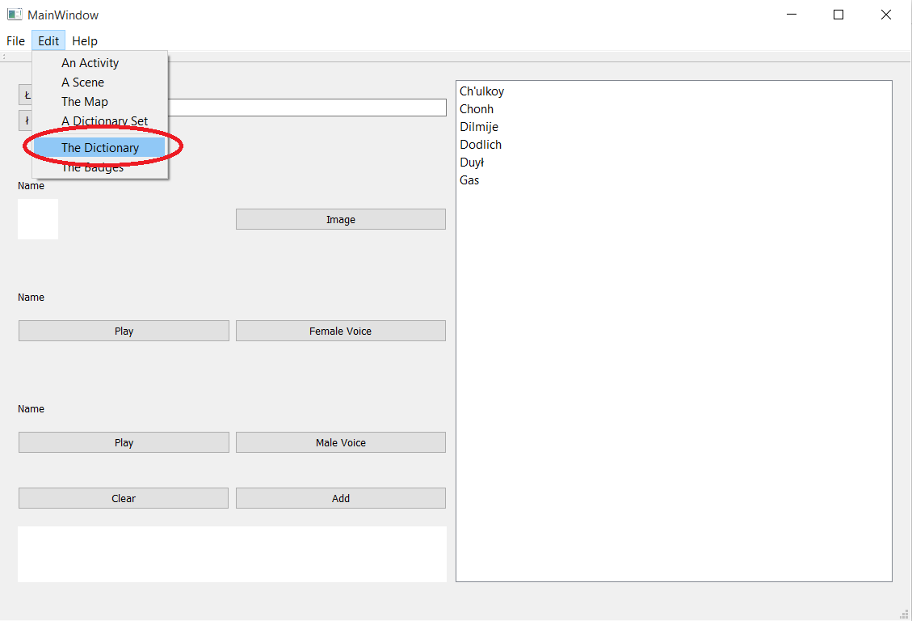

## Error Messages

Explained on page 13

## Adding the Title

To add a Word to the Dictionary, first, add the spelling of the Word. If the dashed L letter is needed, use the two buttons to the left of the field. This is the text that the player will be presented with whenever that word is used:

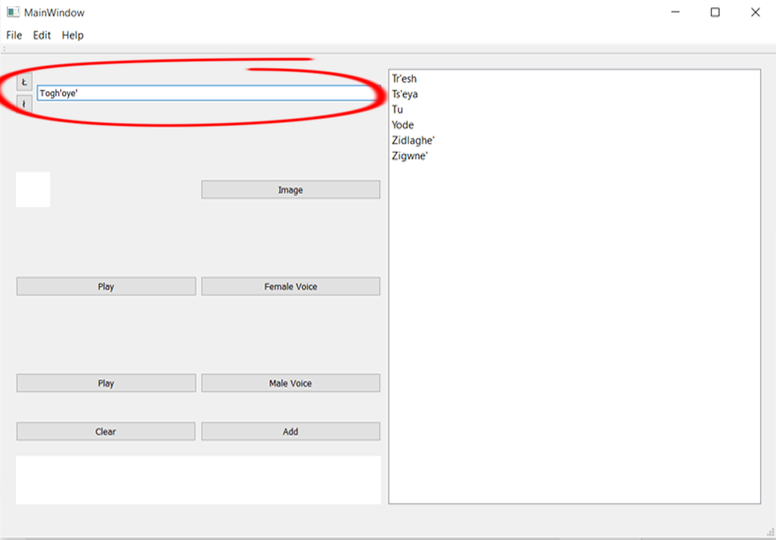

## Adding the Image

Next, click on the **Image** button and select the image that corresponds to the Word:

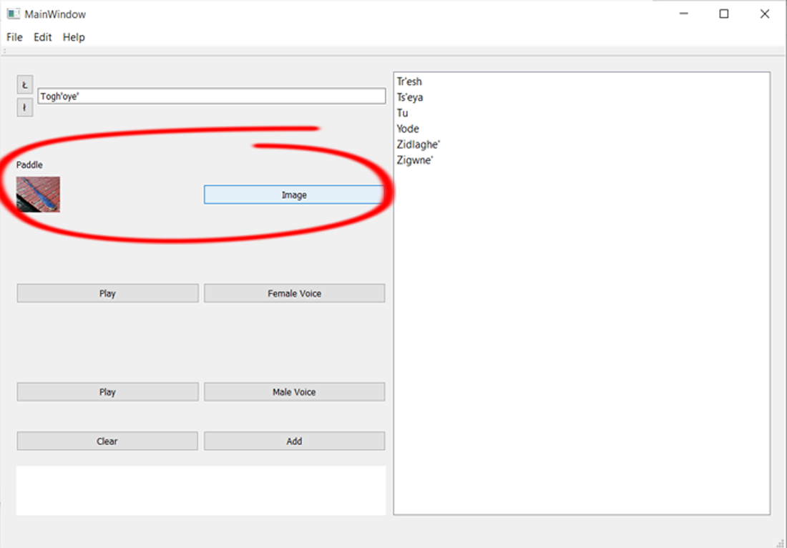

## Adding the Voices

Now, click the **Female Voice** button, which will bring up a window where you can choose the female audio file for the Word, and then do the same for the male audio by pressing the **Male Voice** button:

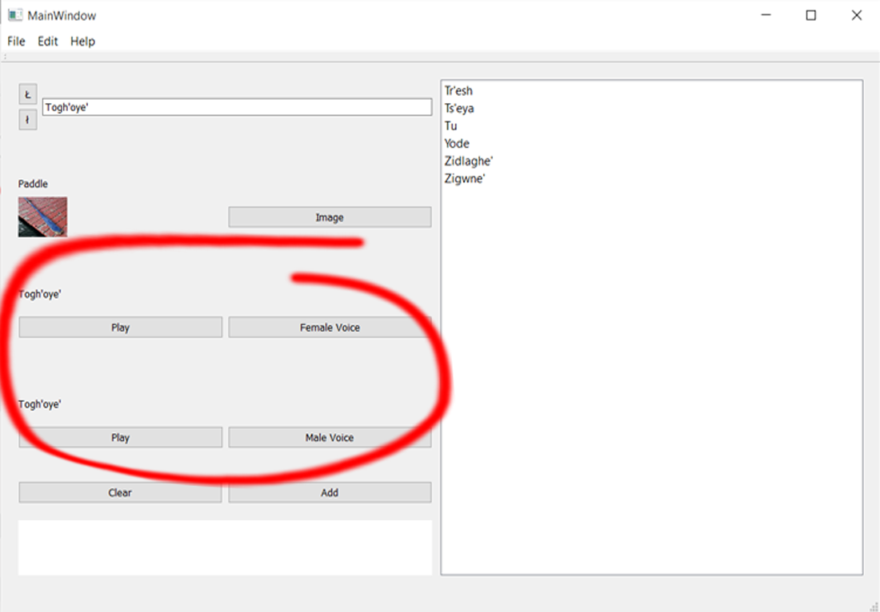

## Adding the Word

The final step is to press the **Add** button to save all of the entered values into a Word in the Dictionary. This will make the new Word appear in the Dictionary list on the right:

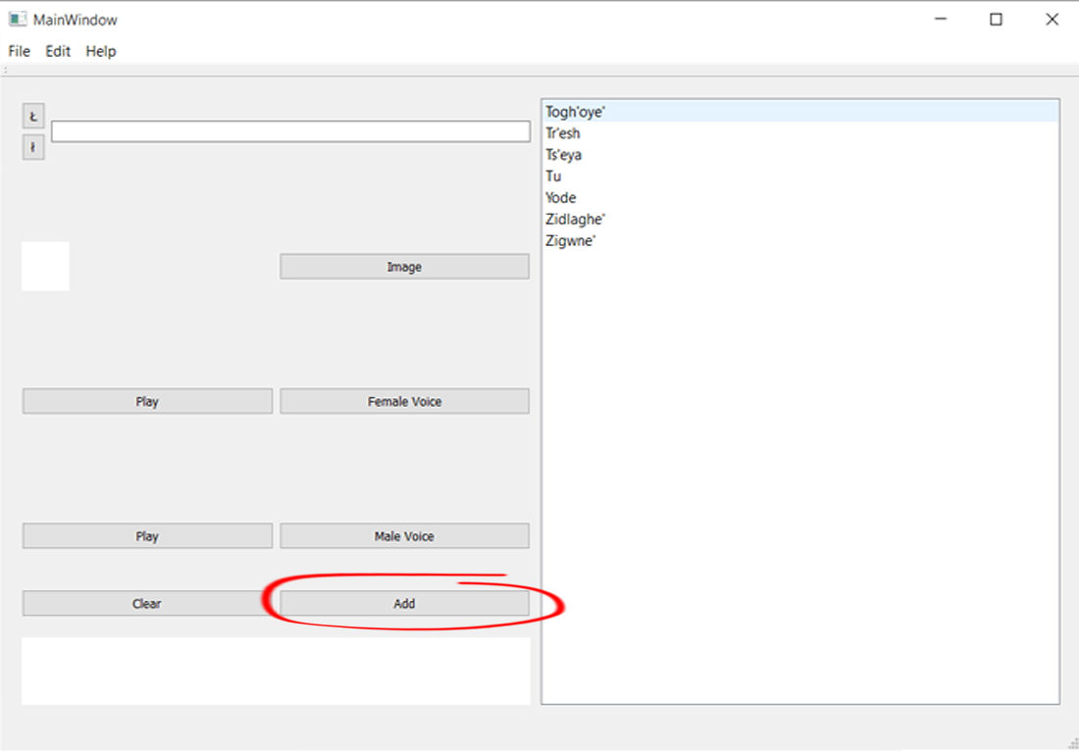

## Clearing the Word

If the entered data is not what was wanted, press the **Clear** button to clear all of the fields:

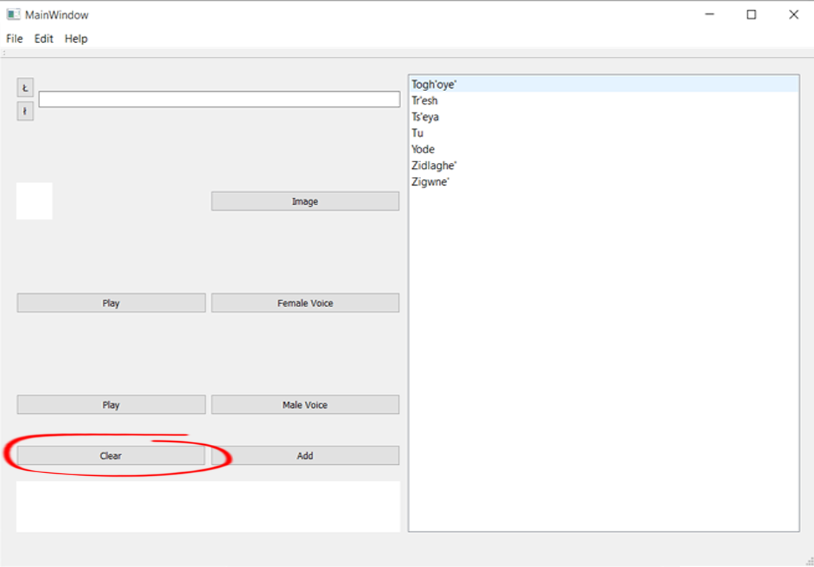

## Editing a Word

To edit Words in the Dictionary, select the word you want to edit. This will fill all of the fields with that Word’s data. To change any of the fields, just select that field’s button and select the correct file, or in the case of the Title, type the correct text. To save changes to the Word, click the Submit button: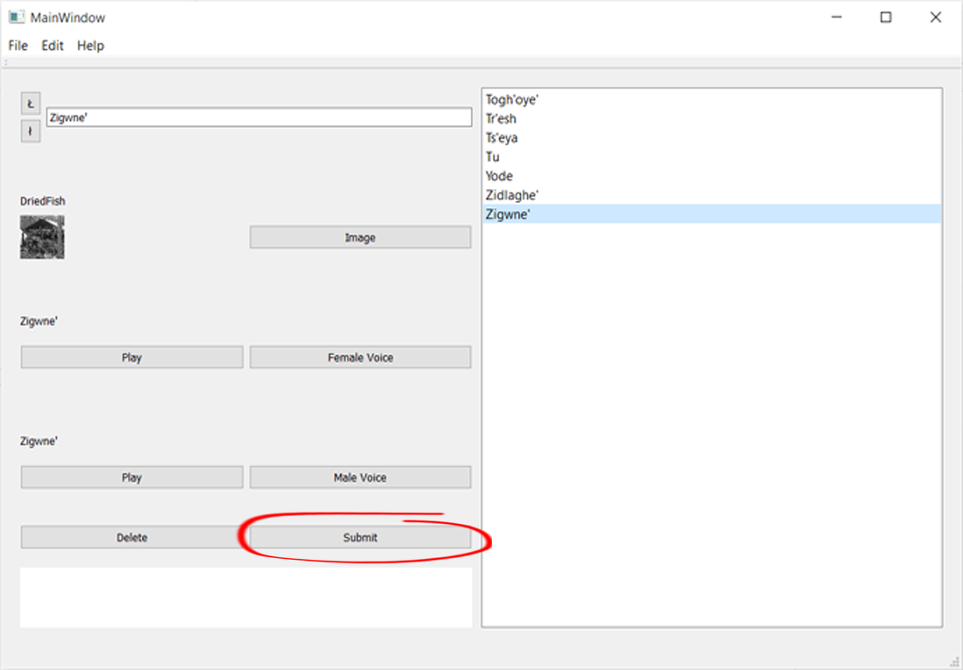

## Deleting a Word

To delete a Word, select the Word from the Dictionary list and then click the **Delete** button:

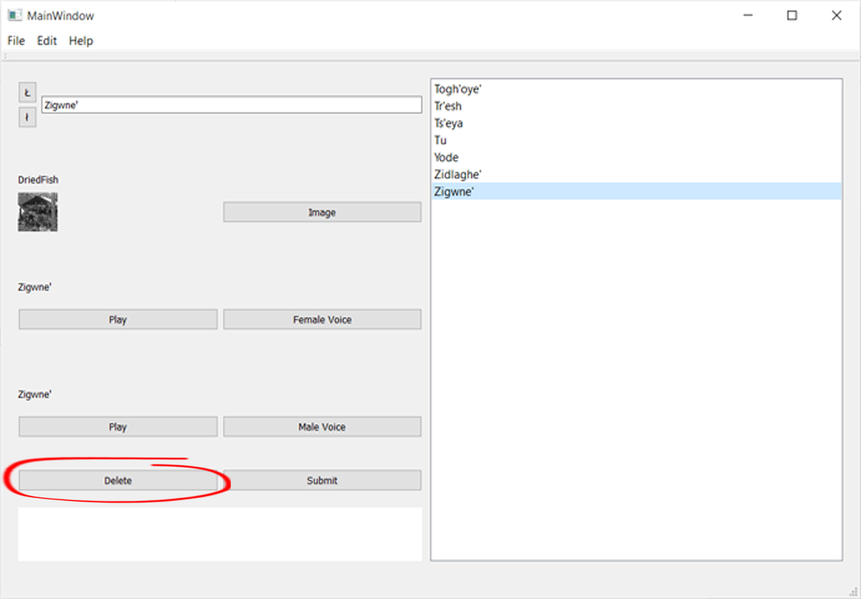

# The Dictionary Sets

The Dictionary Sets are the sets of Words that are used in Activities. They each hold some or all of the Words from the main Dictionary. To create a Dictionary Set, click on **File** in the top toolbar, and then select **New Dictionary Set**. A Dictionary Set requires a unique, non-blank name:

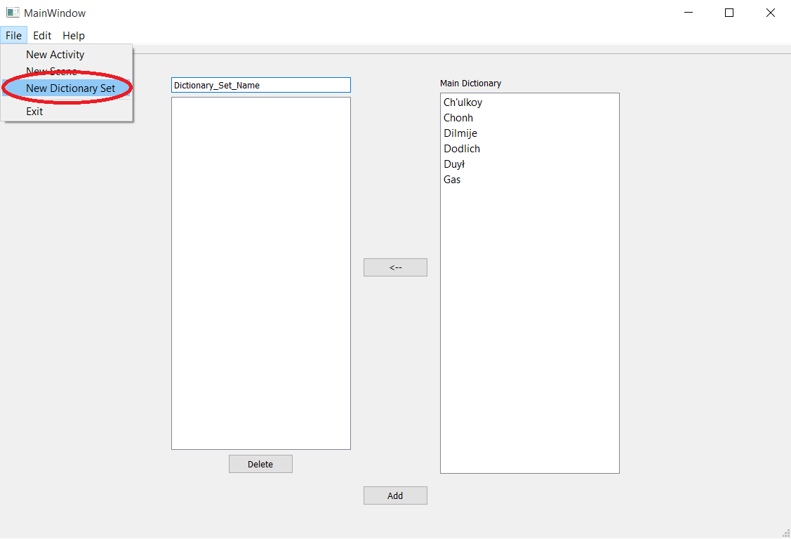

## Error Messages

Explained on page 13

## Naming a Dictionary Set

Each Dictionary Set must have a unique name, and cannot have spaces (use ‘_’ instead). To rename a Dictionary Set, click on the text field above the Dictionary Set list and then type in the new name:

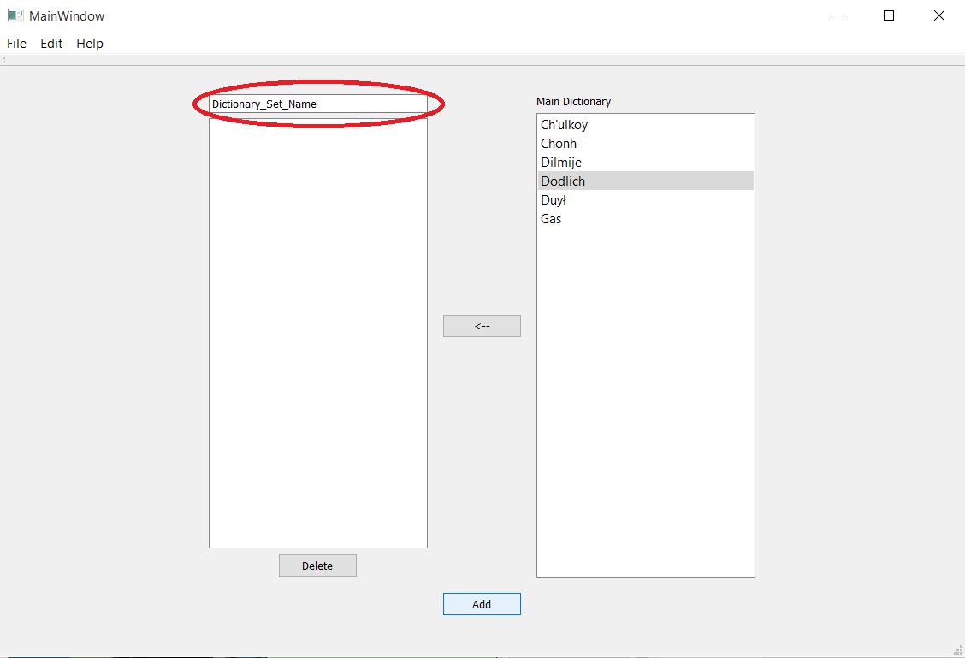

## Adding a Word to the Dictionary Set

The Words added to the Dictionary Set will used by any Activity that has the Dictionary Set as its Dictionary. To add a Word to the Dictionary Set, select a Word from the Main Dictionary, and then press the **🡨** button: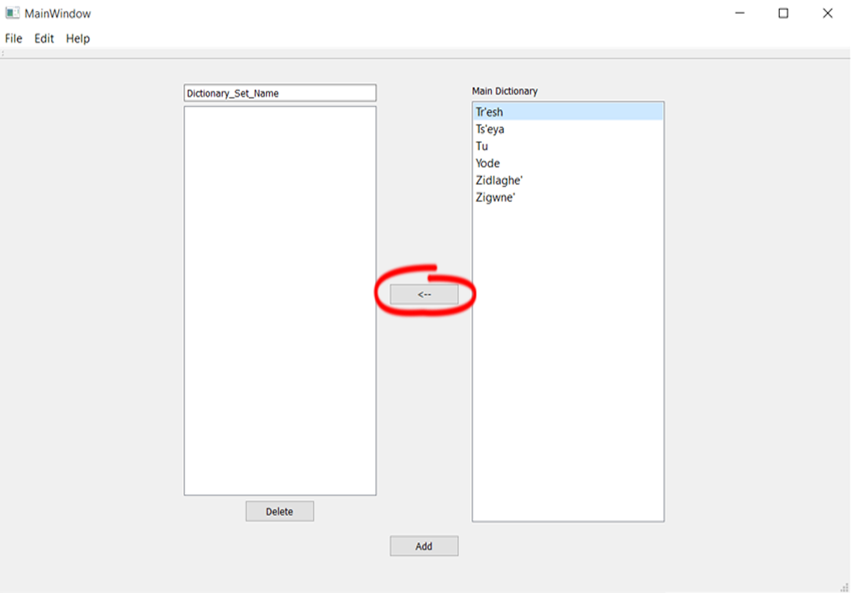

## Removing a Word from the Dictionary Set

To remove a Word from the Dictionary Set, select a Word in the Dictionary Set, and then press the **Delete** button:

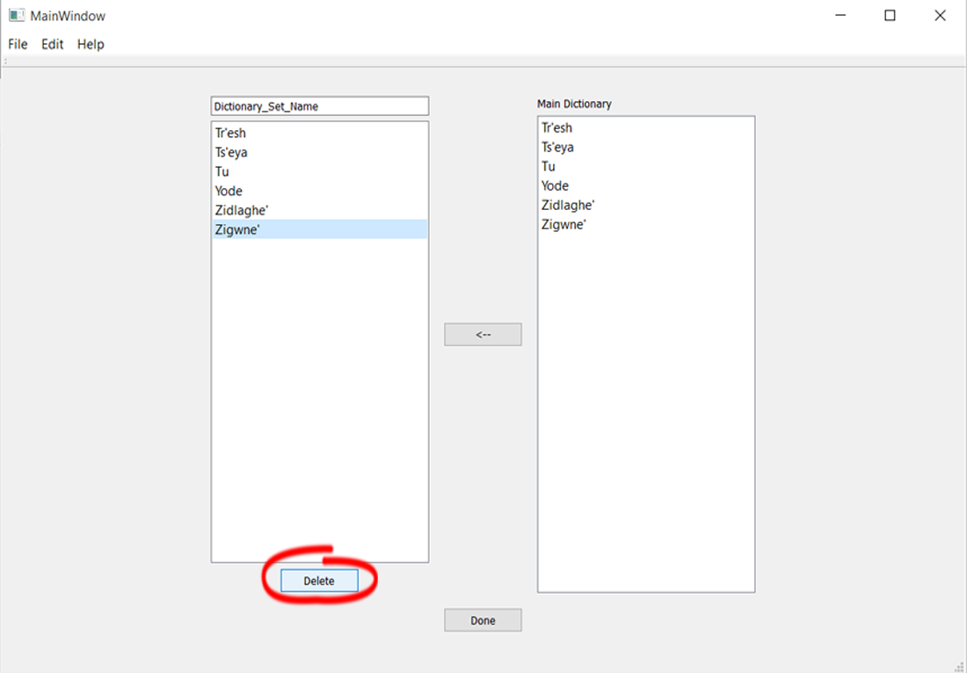

## Saving a Dictionary Set

Once the Dictionary Set has all of the Words it needs, save it by pressing the **Add** button:

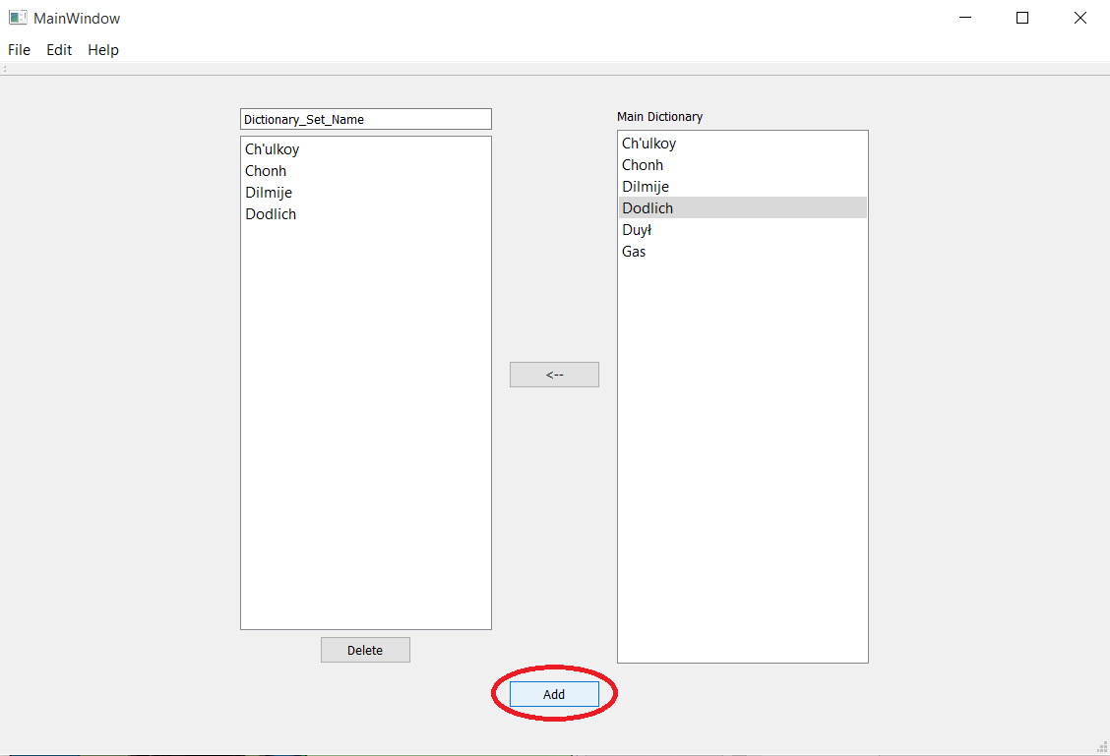

When editing an existing Dictionary Set, the save button will be labeled as **Done**:

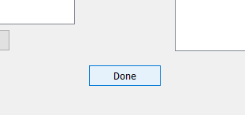

## Editing a Dictionary Set

To edit an existing Dictionary Set, click on **Edit** in the top toolbar, and then select **A Dictionary Set**:

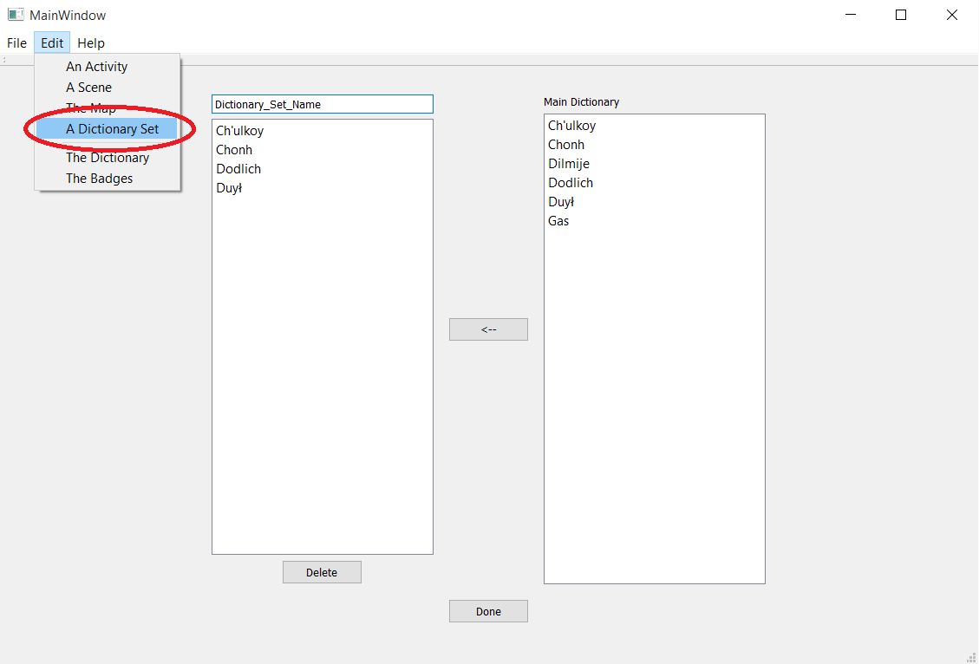

Then select the Dictionary Set that you want to edit from the **Choose a Dictionary Set** dropdown, and then click the **Edit** button:

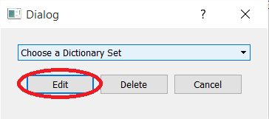

## Deleting a Dictionary Set

To delete a Dictionary Set, click on **Edit** in the top toolbar, and then select **A Dictionary Set**:



Then select the Dictionary Set that you want to delete from the **Choose a Dictionary Set** dropdown, and then click the **Delete** button:

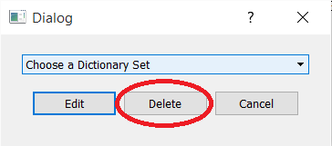

# The Badges

The Badges are the rewards given out to players when they complete all of the Activities in a Scene. The Badge Pieces are handled separately in the screen of each Scene. The Badges can be accessed by going to **Edit** on the top toolbar, and then selecting **The Badges**. To add a new Badge, or save changes to an existing one, the Title and Image must be filled:

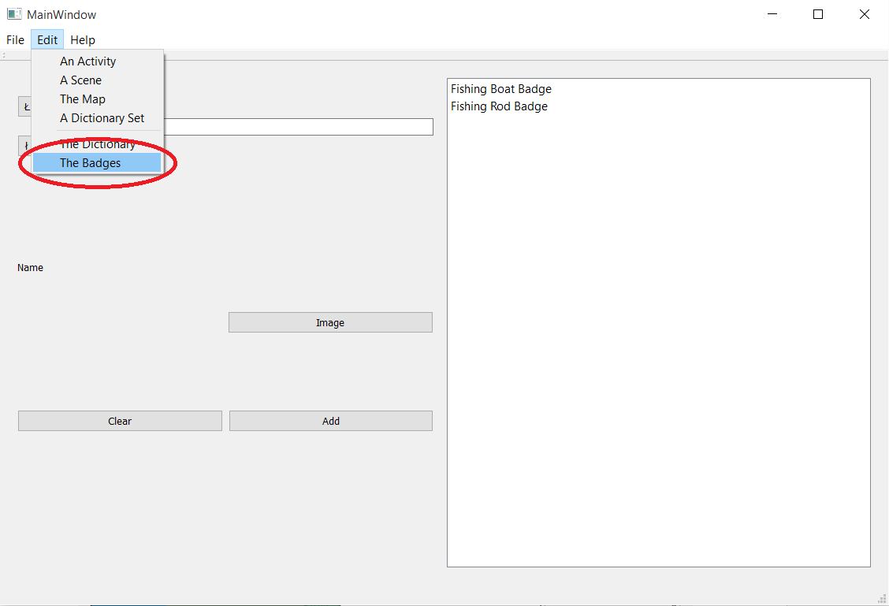

## Error Messages

Explained on page 13

## Adding a Title to a Badge

The Badge Title will be the Hover Text for that Badge that the player will see. To add a Badge Title, type the name of the Badge into the top text field:

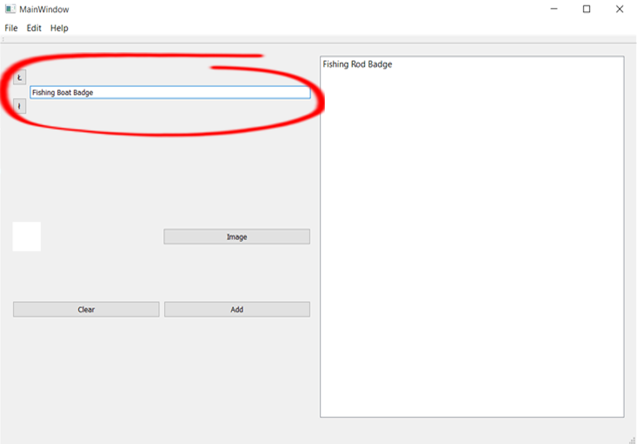

## Adding an Image to a Badge

To add a Badge’s Image, click the **Image** button, which will bring up a window where you can select the image file to represent the Badge:

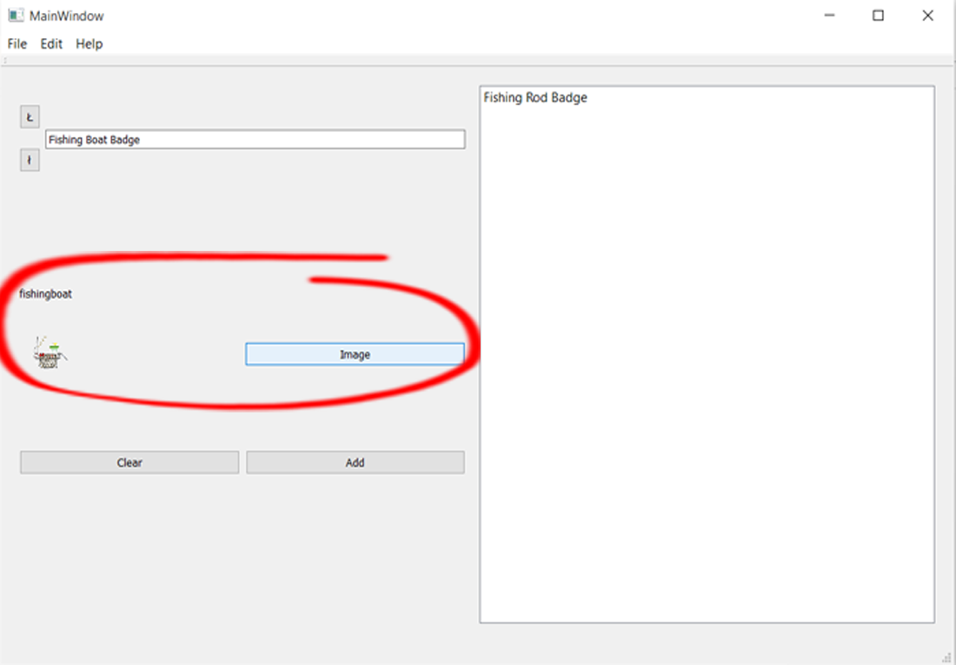

## Adding a Badge to the Badge List

To save a Badge to the list of Badges, click the **Add** button. It will then appear in the Badge List on the right:

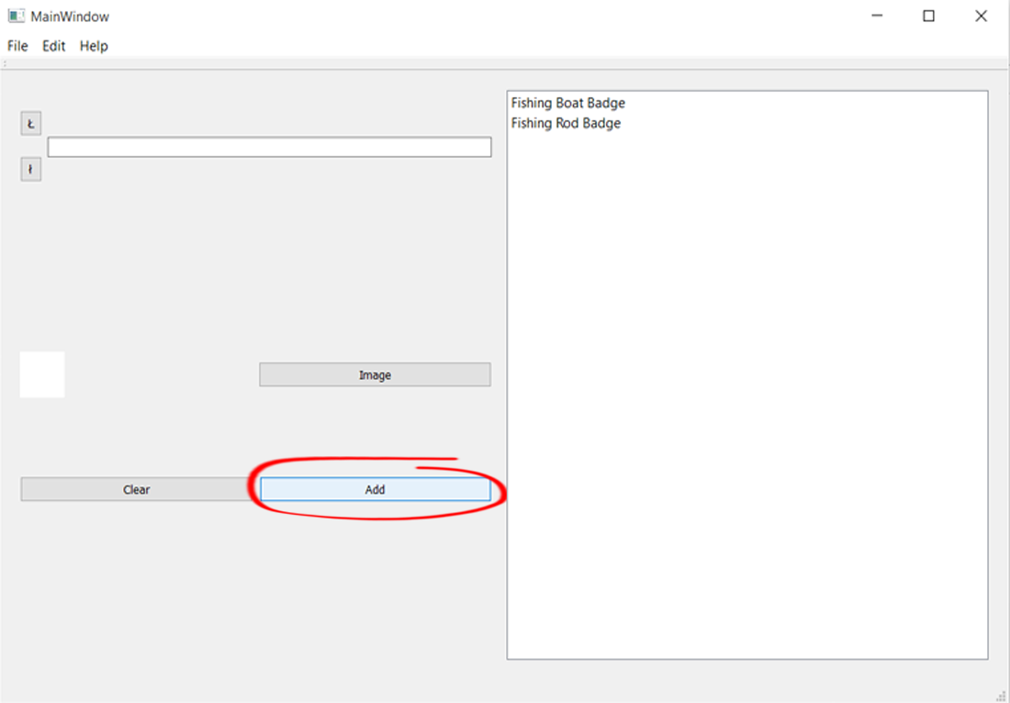

## Clearing a Badge

To clear the fields of a Badge, click the **Clear** button: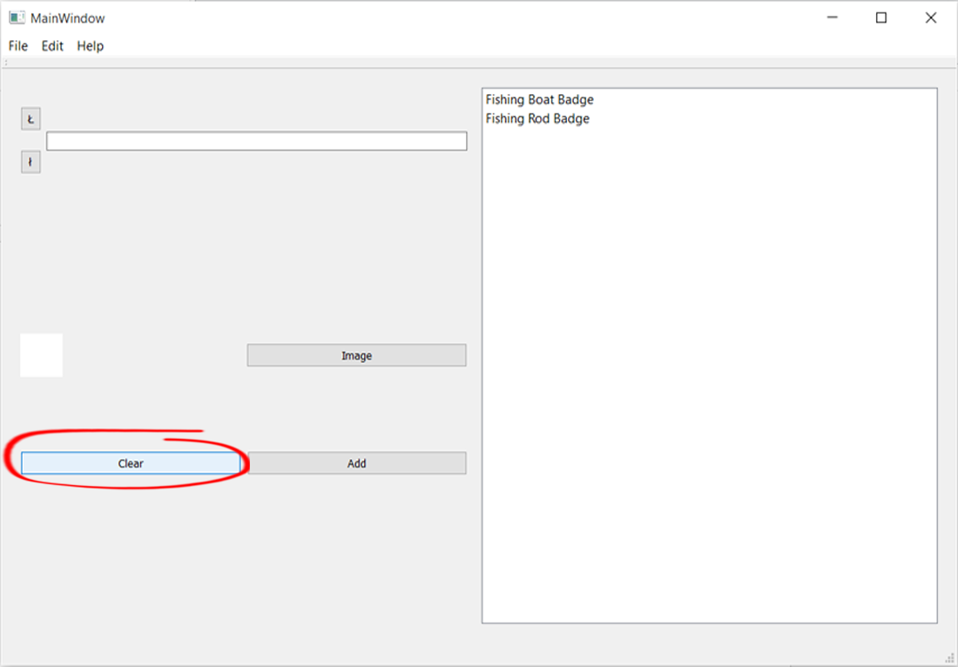

## Editing a Badge

To edit an existing Badge, select the Badge from the Badge List. This will fill all of the fields. You can now change the name and/or the Image. To save these changes, press the **Submit** button:

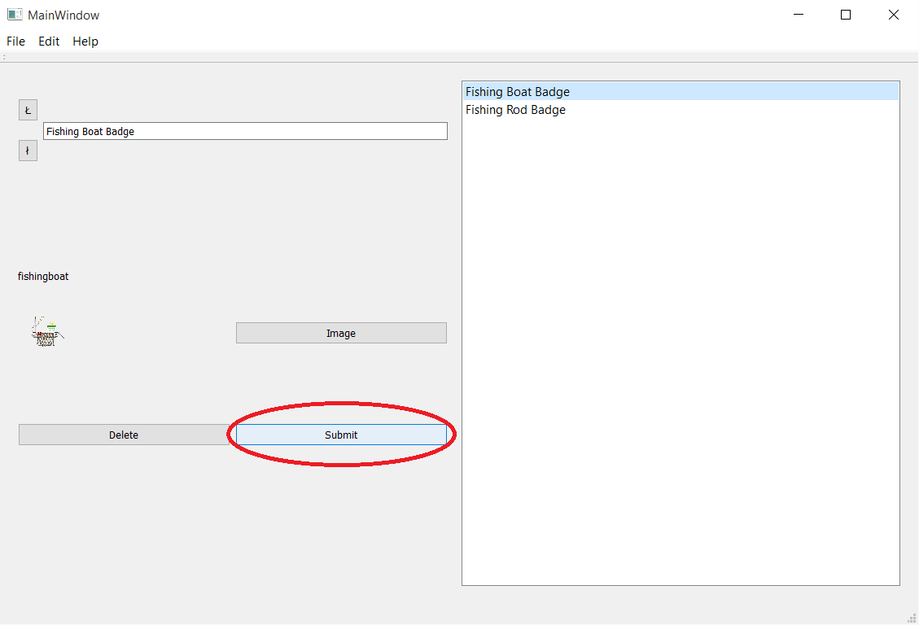

## Deleting a Badge

To delete a Badge, select the Badge from the Badge List, and press the **Delete** button:

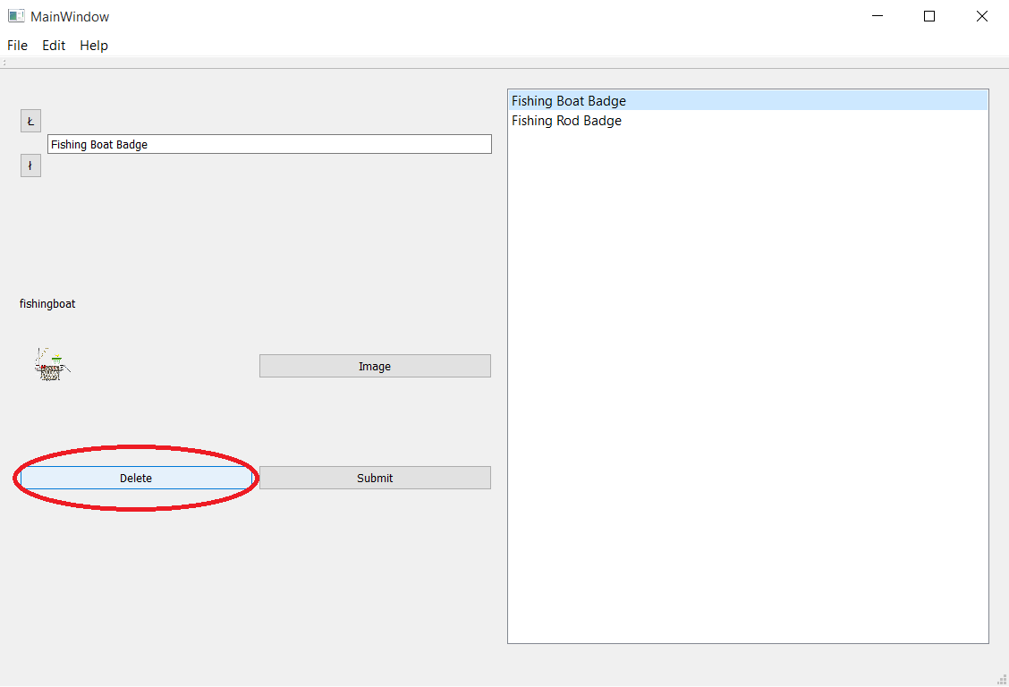

# The Editor

There are two aspects of the Telida Game Editor that can be changed: The initial Image on startup, and the About Page under Help.

## Changing the Editor Intro Image

The startup Image is in the images folder inside of the Dinaki Language Game folder, and by replacing this (the name and file type (.png) must be the same: “EditorIntro.png”), the startup Image can be replaced to whatever the designer wants:

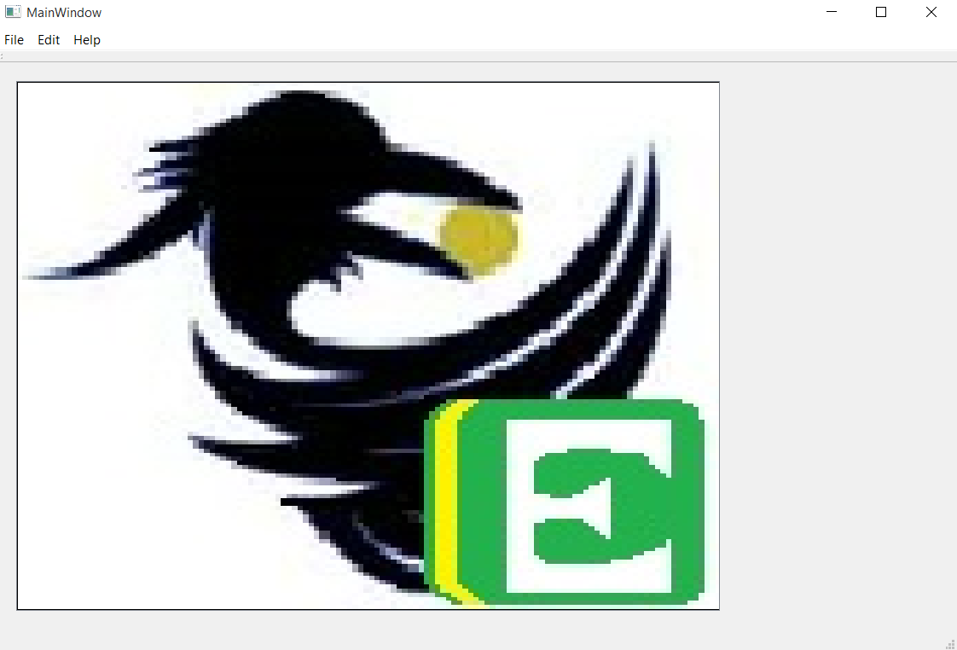

## Changing the About Page under the Help button

The About Page under the Help button explains why the game and editor were made.